
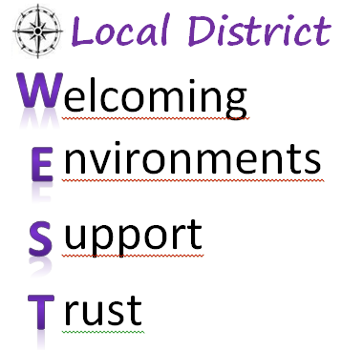
Strategic Implementation Plan:
SCHOOL FAMILY ENGAGEMENT ACTION PLAN
Name of School: _______________________________________________

Strategic Plan  Key Initiatives | Goals: What milestones do you wish to accomplish as a team in 2018-2019? | Action Steps: How will you achieve the milestones you described? | School Staff Responsible | How will you monitor your team’s progress?
Welcoming and Engaging Environment
(Customer Service):

Building Capacity to Engage:
- SSC/ELAC
- LCAP Workshops
- Parent Events/Activities

Parent Portal
Enrollment Strategies:

Addressing Chronic
Absenteeism:

How will this parent engagement action plan assist your school to achieve the student and school climate targets, and instructional goals described in your Single Plan for Student Achievement?

Members of the School Family Engagement Team:

Principal: | Office Representative: |  |  | Family Parent Center Staff:
Teacher/Coordinator: | Other Staff: |  |  | Other Staff:
Reviewed by: |  |  | Meeting with School Family Engagement Team (Optional):
Director: |  | Date:
PACE Administrator: |  | Date:

