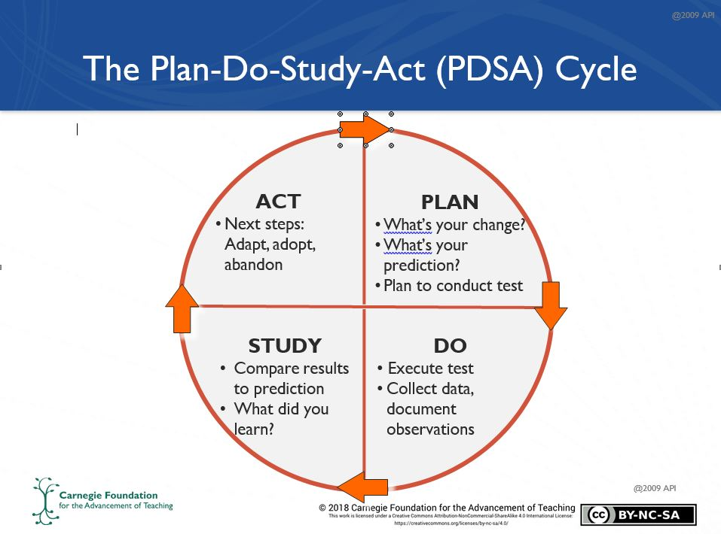

**PLAN - DO - STUDY - ACT (PDSA) CYCLE**

**Name of Tester(s): Name of Supporter(s): Date:**

**Organizational/School Aim:**

**Change Idea Title:**

**Targeted Driver:**

**PLAN**

**Quick Description of the Change Idea:** What will you do? What is the goal of the change idea?

When?

Who?

Where?

|  |  |  |  |
| --- | --- | --- | --- |
| **Questions:** What do you want to learn from this cycle? | **Data:** What data will you collect to answer your questions? | **Predictions:** What do you thinkwill happen? | **Results:** What were the results? What did you learn? *(completed after implementation)* |
| 1. |  |  |  |
| 2. |  |  |  |
| 3. |  |  |  |
| 4. |  |  |  |

**What support do you need from your supporter(s) - to get ready, to collect/analyze data?**

**DO & STUDY (i.e. REFLECT)**

What happened when you implemented the change idea - **observations, surprises, questions, challenges**? What are your **key findings and take-a-ways** from this cycle? *(It is helpful to refer to the “results” in the table above.*)

**ACT (i.e. NEXT STEPS)**

What are possible **next steps**? What adaptations/refinements would you suggest for future cycles? If you recommend abandoning the change idea, why?

**PDSA Reflection Protocol:**

At the bottom of this doc is the team check-in protocol Carnegie shared with us. We haven't created our own typed up version just yet, but below I've taken a stab at it. In general we have found success coaching/talking people through the PDSA form (literally filling it out for/with them and keeping everything housed in the team folder) - helping them reflect on the PDSA they just did and plan the next one. The conversations seem to go something like this:

**Reflecting on the PDSA**:

* What did you try?
* What were you hoping for by trying this intervention?
* What did you learn? What did you notice from the data you collected - any surprises or emerging questions?
* What are possible next steps?

**Planning the next PDSA** (could be a variation on the one just did with the same change idea, or an entirely new idea):

* What would you like to try next? Why? (i.e. how does it connect to your aim/drivers?)
* What do you want to learn?
* What data could you collect to get at that?
* What support do you need - from me and others - to make this happen?
  + (usually this has to do with preparing materials or thinking through data collection; we often take this time to construct data collection tools (i.e. an exit card they can use, a way of tallying types of questions or who talks, etc.). It doesn't need to be fancy, just something that will give them helpful information about how students experience what they try.
  + *By the end of the meeting, we like to have people have a solid plan for what they want to do and tools for how to collect data on it, so it is easy to put it into practice immediately. Our mantra has become "No homework for teachers. Do the work together in the meeting."*

*A final thought about data:* If teams are feeling stuck with data, it can help to remind them that they don't need to collect big d data about their aim every time they do a PDSA. Some of the most valuable PDSA data can simply be feedback from students about what worked or didn't, or even teacher's own observations of particular behaviors they were after. It can also be helpful to think about what sorts of things they can be tracking over time as they try different change ideas so that they can create run charts like the one we did for energy level (nice examples of this include attendance data, work completion, and even excitement or confidence levels rated on a scale from 1-5 like in the sample exit card we showed everyone at the convening).

