**Driver Diagram Generation Protocol**

***The purpose of this protocol is to generate a shared “theory of action”***

***to drive a team’s improvement efforts and ultimately achieve the aim.***

*Note: Driver diagrams are not intended to be set in stone. Your team’s theory of action should evolve as you learn more about the problem/gap you want to address, the change ideas you are trying, and how best to achieve your aim.**We encourage teams to revise your driver diagram to reflect your most current thinking/focus, and to keep track of versions 1.0, 2.0, etc. so you can reflect on the evolution of your learning.*

**Norms**:

* **“Yes, and”**... the goal is to generate lots of ideas, not fixate on one
* **Embrace “definitely incomplete; possibly incorrect”**
* **Share the air**

**Some helpful definitions:**

* ***Aim***= what you want to accomplish for whom by when (samples below)
* ***Primary Driver* (*the what*)** = what you need to focus on to achieve your aim (i.e. *financial literacy***)**
* ***Secondary Driver* (*the where*)** = where in your system (the existing structures/processes) you should focus your energies to effect the primary driver (i.e. *parent workshops*)
* ***Change Idea* (*the how*)** = what you can try and test/refine (i.e. *Families complete the FAFSA together at the monthly parent meeting)*

**Protocol:**

1. **Clarifying/Refining our Aim (10 minutes)**

***As a group, craft/refine your aim statement:* *What do you want to accomplish, for whom, by when?***

It can help to begin by having each person, individually or with a partner, craft an aim statement. Follow this with a whip where each person/partnership shares their aim with the group. Then the group can adopt/adapt from these to create an aim statement everyone feels good about. *Write your group’s aim statement on the left side of your poster.*

*Some things to consider*:

* Is your aim ***measurable***? To help ensure your aim is measurable, it can be helpful to ask yourselves this question: “If X was the best it could be, what would it look like?” It can also help to get baseline data related to the issue/gap your team is working on.
* **Some sample aims:**
  + By Spring 2015, all HTHNC seniors will apply to a 4-year college.
  + By the end of 15-16, CAT HS will decrease our % of students who need remedial Math & English courses in college from 85% to 50%.
  + By May 2016, 60% of seniors at John Muir HS will score a 3 or 4 on the first reading of their senior research paper (compared to 20% last year).

1. **Identifying Primary Drivers (20-30 minutes)** 
   * ***Individual (no more than 5 minutes)*:** Each person identifies the top 4 drivers (i.e. *high leverage areas*) they think the team needs to focus on to impact the aim, and writes each driver on a separate index card.
     + **Facilitation Move**: It can help to think of drivers as X in the following statements: “If we figured out X, we could achieve our aim” or “If we don’t figure out X, it is unlikely we would achieve our aim.”
   * ***Whip & Cluster*:** Each person shares their favorite driver with the group. If others wrote down a similar driver, group these cards together on the table.
     + **Facilitation Move**: As your group shares and clusters, it can be helpful to organize the “stacks” with the most cards to the top of the table, and those with the least to the bottom. This gives the group a visual indicator of which drivers might be most important.
   * ***As a group, select 3-5 drivers*** that you think are essential for impacting your aim. Write those drivers on your driver diagram poster. This is your “theory of action” (i.e. if you could move these drivers, you could achieve your aim).
     + **Questions for the team to consider:**
       - Is this driver ***specific*** enough that we all understand what to focus on?
       - Is this driver ***impactful*** enough that it will move the work forward?
       - Is this driver within our ***locus of control***, meaning we can do something about it? (i.e. Poverty is real, but may not be a helpful driver. However, Family Support could be an important driver and signals a way of working with families to reduce the effects of poverty.)
       - Are these drivers ***necessary and sufficient*** for achieving our aim?
       - Which driver do we think is our ***greatest lever*** for change? **(Star this one.)**

**3. Identifying Secondary Drivers (if time permits)**

If your team has time, you can add secondary drivers to your diagram. Secondary drivers articulate

“where” in the system (i.e. what structures and processes) you can focus your efforts to impact the primary

drivers. They can be helpful for focusing the team’s efforts and coming up with more concrete change

ideas. For example, helpful secondary drivers may be Advisory, Teacher PD, Number Talks, Classroom

Meetings or Master Schedule.

**4.**  **Generating Change Ideas (15 minutes)**

* + ***Individual Brainstorm (3 minutes)*:** How might we impact the drivers we identified? What might we try? Where is this happening well already (bright spots), and what are they doing? *Write each idea on its own post-it.*
  + ***Share & Align (10-12 min):*** Individuals share their ideas with the group, and post each change idea by the driver they feel it most impacts. *(helpful questions to consider on the next page)*
    - **Question for the team to consider:**
      * What do we notice about the ***alignment*** (or lack of) between our change ideas and drivers? (If you have lots of change ideas that don’t align to your existing drivers, this could suggest a new driver is needed. If you have a driver without any change ideas, this driver may not be helpful to your current “theory of action”.)
  + ***Identify high leverage change ideas*:** As a group identify 3-5 change ideas that you think are most impactful, and that you could get moving on quickly (i.e. those in the upper left quadrant of the below picture). **Star these on your driver diagram.**

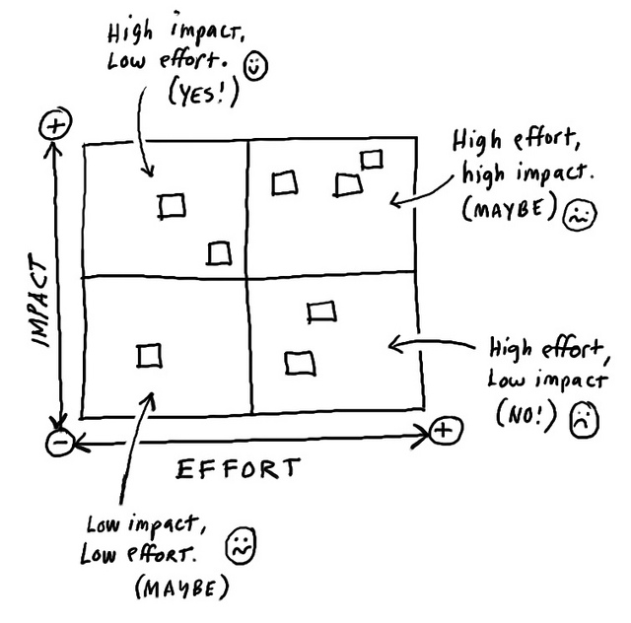

**5. Debriefing the Process** (5 minutes)

Group members discuss the following questions:

* How well did we do with upholding the norms and sticking to the protocol?
* Was this protocol helpful for identifying high leverage drivers and change ideas?
* What worked well about this protocol? What could be improved?

This protocol has been created by the High Tech High GSE Center for Research on Equity and Innovation

Title: Theory of Action for X

**Primary Drivers (The What)**

**Secondary Drivers (The Where)**

**Change Ideas (The How)**

**Measures**

**Goal**

What do you want to accomplish, for whom, and by when?

*If we want to improve [GOAL], then we need to focus on [PRIMARY], through [SECONDARY], and one way to do that is [CHANGE IDEA].*

Adapted from the template created by the High Tech High Graduate School of Education Center for Research on Equity and Innovation.

https://docs.google.com/presentation/d/16n2DWX4ebWTgFNyq7rKCwyFo2CglBJlRZo6pHFmqg8Q/edit#slide=id.g1071ef0571_0_0

**Definitions and Directions**

**Some helpful definitions:**

* ***Goal*** = what you want to accomplish, for whom, and by when
* ***Primary Drivers* (*the what*)** = what you need to focus on to achieve your Goal
* ***Secondary Drivers* (*the where*)** = where in your system (the existing

structures/processes) you should focus your energies to effect the Primary Drivers

* ***Change Ideas* (*the how*)** = what you can try and test/refine

Once you have identified your Primary Drivers, Secondary Drivers, and Change Ideas you can use arrows to link them together. Using the sentence in the left bottom corner of the first slide can help identify chains of causation.

California Department of Education December 2017