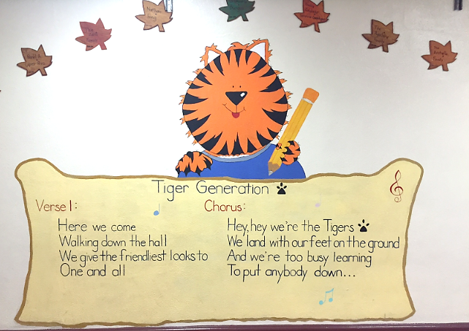

Tiger Generation is a song from the students at Garvanza Elementary School, reminding all students that the Tigers are friendly and ready to learn!