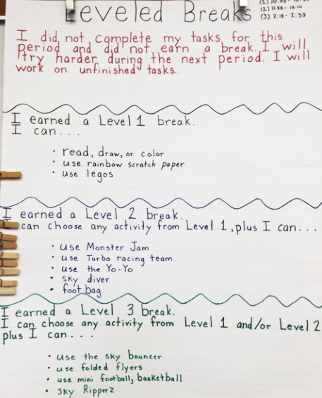

The Leveled Breaks system is used in a classroom at Beckford Elementary School. Student earn breaks by completing tasks. Choices of activities increase at each of the three levels.