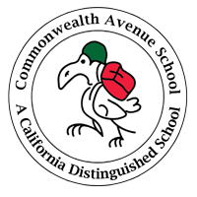 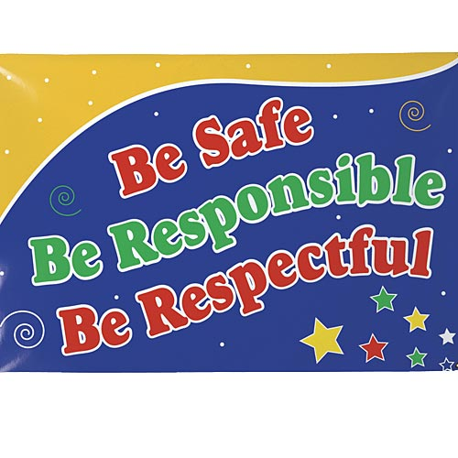

Dear Commonwealth Ave. Elementary Parents,

***Have you heard the buzz about our new school initiative? – Positive Behavior Intervention and***

***Support!***

Positive Behavior Intervention and Support is a program supported by the California Department of Education and LAUSD Schools to promote and maximize academic achievement and behavioral competence. It includes comprehensive school-wide strategies for helping all students achieve important social and learning goals. We know that when good behavior and good teaching come together, our students will excel in the social skills, and work habits foundational to high achievement. Commonwealth Ave. Elementary is proud to be a part of this exciting initiative.

As part of the PBIS program, we have established several clear rules for the behavior we expect in all areas of our school. We explicitly teach those expectations to the students and reward them frequently with positive notes and prizes for their great behavior. The expectations for all student behavior are being clearly posted throughout our buildings and playground areas, cafeteria, auditorium, and classrooms. You will be able to ask your student, “What are the rules in your school?” “How do you follow those rules?” “What happens when a teacher sees you following the rules?”

Our school rules specifically address bullying behaviors, provide for a safer school environment and give more time for instruction. We will apply consistent consequences and positive reinforcement for all kids. By detailing every expected behavior /consequence and teaching to kids in a positive way, we will be providing a common language for everyone in our school, including students, staff members, and parents.We believe that by helping students practice good behavior, we will build a school community where all students have an environment where they can feel safe to succeed and grow. **We would like your input and your involvement. Please return the bottom portion of this flyer to Ms. Barbara Cruse. Thank you for your support!**

I want to participate on the SWPBIS team!

Name________________________________________________________________________________

E-mail________________________________________________________________________________

Phone________________________________________________________________________________

Student(s)____________________________________________________________________________

Grade (s) _____________________________________________________________________________

|  |  |  |  |
| --- | --- | --- | --- |
|  | Bee-Cartoon**Safe** | Bee-Cartoon **Respectful** | Bee-Cartoon**Responsible** |
| **Yard/ Playground** | * Play and stay in assigned area. * Keep hands, feet and objects to yourself. | * Follow the rules of the game. * Take turns. | * Use the bathroom and drink water before the bell rings. |
| **Bathrooms** | * Keep your feet on the floor. * Wash your hands. | * Keep the bathroom neat and clean. * Give people privacy. | * Throw all paper towels in the trash. * Use only what you need. |
| **Hallways /Common Areas** | * Walk in the hallways. * Walk up and down stairs. | * Use quiet voices. * Keep hands away from bulletin boards. | * Go directly to class. * Carry a hall pass. |
| **Lunch Area** | * Walk to assigned tables. * Sit and eat at your assigned table. * Keep hands, feet and food to yourself. | * Use quiet voices * Follow adult directions | * Stay seated until dismissed * Clean up all trash |
| **Auditorium** | * Walk to seating area. * Keep hands and feet to yourself. | * Use good audience manners. * Stay seated. | * Listen and watch presentations quietly. * Allow others around you to enjoy the event. |

**Commonwealth Avenue Elementary School**

***Condor Code of Conduct***

**School-Wide Behavior Expectations**

*COMMONWEALTH AVENUE ELEMENTARY SCHOOL*

**Plan for Safe, Respectful, and Responsible Behavior**



**BEE Safe…**

**BEE Respectful…**

**BEE Responsible…**

**Teasing/ Bullying**

Teasing or bullying is not allowed on school grounds and may result in writing a Reflective essay or a Time Out Journal. Parents will be notified. Repeat offenses will result in suspension.

**Hitting, Pushing & Kicking**

If a child hits, pushes, kicks another student it will result in an office referral. Consequences include conference with teacher, child and parent, Reflective essay/ Time Out Journal, and benching during recess and lunch.

**Bad Language**

Using inappropriate language will result in a verbal warning, being benched, and a Reflective essay/Time Out Journal. Parents will be notified and repeat offenses will result in an office referral.

**Not following Playground rules**

Students are expected to stay in their play area and follow the rules. If students are not following the rules, they will be given 3 verbal warnings. If students continue to break the rules, an office referral will be written.