TEACHER VISUAL TEXT FOR CONVERSATION PATTERN
USE FOR LESSONS 2-4

STUDENT VISUAL TEXT FOR CONVERSATION PATTERN PRACTICE
USE FOR LESSONS 2-4


USE THROUGHOUT THE UNIT – TEACHER VISUAL TEXT
USE THROUGHOUT THE UNIT – STUDENT VISUAL TEXT

USE THROUGHOUT THE UNIT – TEACHER INFOGRAPHIC
USE THROUGHOUT THE UNIT – STUDENT INFOGRAPHIC (EM-EX LEVEL)
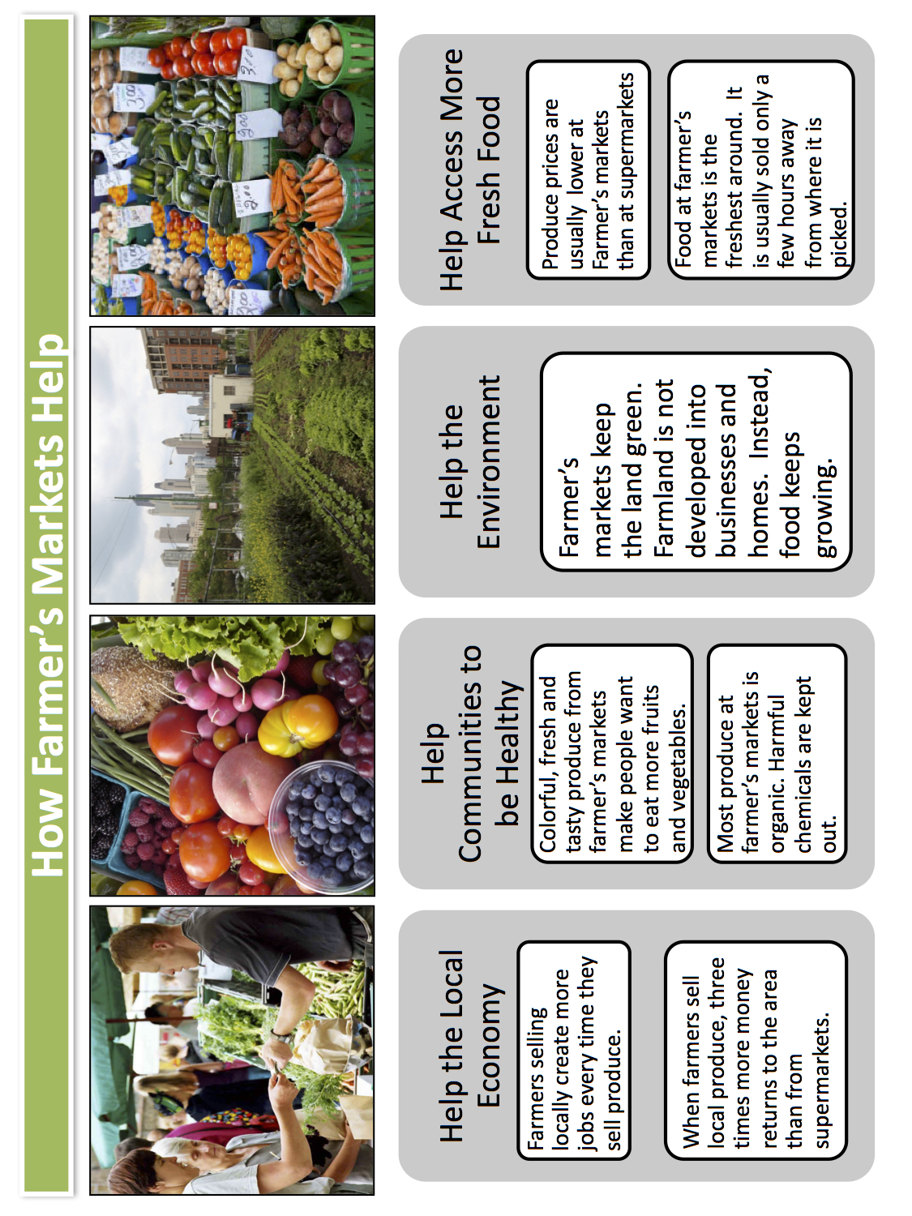

DIFFERENTIATED TEXT – Optional Student Infographic for Students Working at Emerging (EM) Level
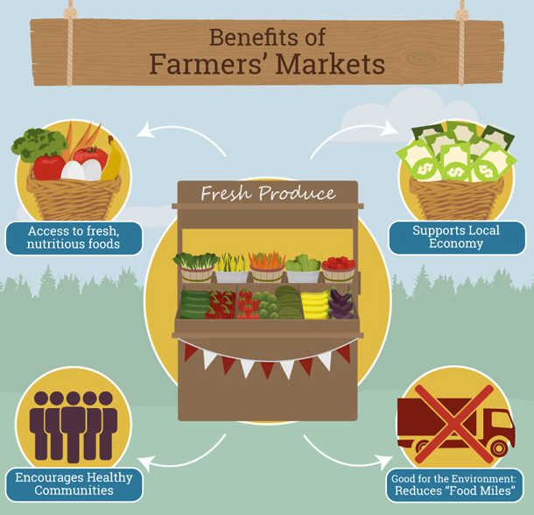
DIFFERENTIATED TEXT - LESSONS 12-21
Optional Student Visual Text

DIFFERENTIATED TEXTS - LESSONS 12-21
Optional Student Infographic for Students Working at Bridging (BR) LEVEL
