### Los Angeles Unified School District

333 S. Beaudry Ave., 24th floor

Los Angeles, CA 90017

Phone: (213) 241-6766

FAX: (213) 241-8952

www.lausd.net

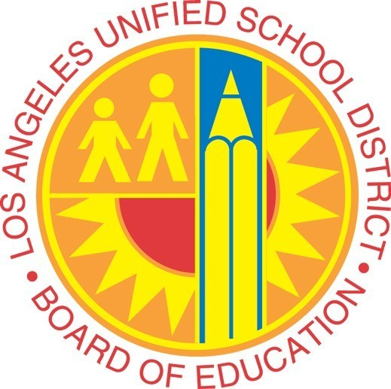

**Media Advisory**

|  |  |
| --- | --- |
| **Contact:** Monica Carazo (213) 247-4087 | February 23, 2018  #17/18-141 |

**Student-nominated Sal Castro Awards**

**WHAT:** One of many commemorative events for the 50th anniversary of the 1968 Walkouts hosted by L.A. Unified Board President Mónica García will begin this weekend with the Sal Castro Awards.

Two teachers and/or counselor from the five legacy high schools (Belmont, Garfield, Lincoln,

Roosevelt and Wilson) will be honored for their exemplary service to students and community in

the areas of:

* Leadership development of youth; Civic engagement
* Education around social justice issues; Advocate for equity and access to college/career pathways

**WHO**: L.A. Unified School Board President Mónica García

Local District Central Superintendent Roberto Martinez

Local District East Superintendent Jose Huerta

**Awardees**:

Belmont High School: Stephen Calhoun, LAAMPS (small learning community) counselor and John Zunino, math teacher

Garfield High School: Juan Garcia, social studies teacher and Deana Duran, counselor

Lincoln High School: Arthur Licon, voice, Spanish and Chicano Studies teacher and

Daniel Alamo, social studies teacher

Roosevelt High School: Jorge Lopez, Ethnic Studies teacher and Vera Cline,

counselor/teacher

Roosevelt Magnet: Mariana E. Ramirez, history teacher

Wilson High School: Rodolfo Duenas, history teacher and Elsa Gutierrez-Aviles, college advisor

**WHEN:** Saturday, Feb. 24

**TIME:**    9:30 a.m. to 12:30 p.m.

**LOCATION:**  East Los Angeles College

**Multipurpose Room- Student Union Building F5**

                      1301 S. Avenida Cesar Chavez

                      Monterey Park, CA 91754

**BACKGROUND:** Salvador B. Castro was a Mexican-American educator and activist.

Mr. Castro, known as “Sal,” was a social studies teacher at Lincoln High School. He guided student walkouts at five predominantly Mexican American schools on the Eastside in what came to be seen as a milestone in community activism.

**###**