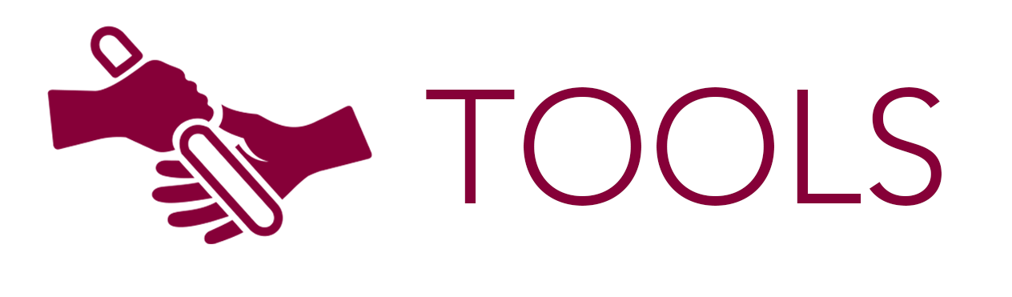


SWOT Analysis Pre-work Sheet

As you prepare to participate in a SWOT analysis group process, this work sheet will help you consider contributions you can make in that discussion. Each aspect of the SWOT includes questions you can consider and space for recording notes which may guide your input in the group process.

Strengths | Weaknesses
- What does your agency do well?  - Do you have unique resources or competencies to draw on?  - What do others—the public, your employees, other agencies, partners—see as your strengths?  - What unique or lower cost resources do you have access to?  - What do you do better than other comparable agencies or the private sector?  - Why are you an “employer-of-choice”?  - How are you a leader in your service or regulatory sector?  - Why are you confident about the future? | - What could you improve?  - Where do you have fewer resources or competencies than needed?  - What do others—the public, your employees, control agencies—see as your weaknesses?  - Are other agencies similar to you doing better in key areas?  - In what ways are you not competitive?  - Is there a general organizational awareness of and resolve to improve weaknesses?  - Why do you lose strong performers?  - Is there an “elephant in the room”—a really big problem—your agency will not address?
Notes: | Notes:
Opportunities | Threats
- What opportunities are open to you now?  - What current business or social trends can you use to your advantage?  - Can you turn a current strength into a new opportunity?  - Are there changes in technology or law/regulation than can help you?  - Are there changes in your customer or employee demographics that could benefit you?  - Are there upcoming events or predicted changes that can you can leverage?  - Are there fundamental changes coming in government—local/state/federal—that can benefit you? | - What current or future trends could harm you?  - What is your competition—competition for labor or providing services—doing better than you?  - Do current weaknesses expose you to new threats in the future?  - Will changes in technology put you at a disadvantage?  - Is anything threatening your influence with political or fiscal decision-makers?  - Are there big “unknowns” that can jeopardize the agency’s future?  - What external forces—economic, social, financial, legal—could most harm you in the near term or long term?
Notes: | Notes:

