**How to use the Sub Days Tracker**

**Background:**

The sub days tracker was designed to help substitute teachers, time reporters, and administrators adhere to the legal restrictions related to the 30-day sub permit and to specify what the legal restrictions are. The tool only counts school days and has already removed any days that are not school days based on the current school calendar.

**What is a 30-day substitute teaching permit?**

A 30-day substitute teaching permit is a document issued by the California Commission on Teacher Credentialing to allow them to temporarily cover classrooms during a teacher’s absence with the following restrictions:

* The Emergency 30-Day Substitute Teaching Permit authorizes for no more than 30 days for any one GENERAL ED classroom during the school year.
* The Emergency 30-Day Substitute Teaching Permit authorizes the holder to serve for no more than 20 days in any one SPECIAL ED classroom during the school year.
* This tool was created to help school site staff and substitute teachers with adhering to the restrictions of substitutes who are authorized by 30-day sub permits.

**How do I use the Consecutive Sub Day Tracker?**

To use the tool, please place the 1st day the sub reports to the class in cell **K2** to find out the last consecutive day their permit authorizes them to work in the class.

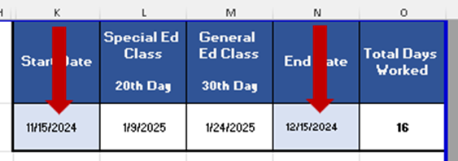

To calculate the total number of consecutive days spent in one classroom, place the start date in cell **K2**, place the end date in cell **N2,** O2 calculates the number of school days between K2 and N2.

**How do I use the Cumulative Sub Day Tracker?**

For non-consecutive /intermittent days worked in the classroom, please put the first date in column **E**, the last date in column **F** for each time the substitute teacher works in the same classroom, then the days worked will be counted for you and totaled for the year. Please see the example below:

* In this example, the substitute is no longer authorized for this general education classroom after 3/14/2025.
* In the same example, the substitute would no longer be authorized in a special education classroom after January 24th because that was the 20th day served in that classroom.

To minimize mistakes, the only cells that you may edit are those in columns **E, F, K** and **N** that are shaded light blue. All other cells are locked and may not be edited.

**Why are there tabs for each month?**

Monthly calendars with notes are available to help track other details such as holidays, unassigned days and any other relevant information.



For more information about substitute teachers or how to use the tracker, please email [SubDesk@lausd.net](mailto:SubDesk@lausd.net).