**How to use the Sub Assignment Monitoring Tool**

**Background:**

The Sub Assignment Monitoring Tool helps substitute teachers, time reporters, and administrators adhere to the legal restrictions related to the 30-Day Substitute Teaching Permit and to specify what the legal restrictions are. The tool only counts school days and has already removed any days that are not school days based on the current school calendar.

**What is a 30-day substitute teaching permit?**

A 30-Day Substitute Teaching Permit is a document issued by the California Commission on Teacher Credentialing to allow a substitute to temporarily cover classrooms during a teacher’s absence with the following restrictions:

Substitute teachers have limitations regarding how long they can serve in a substitute capacity in a school year for any one teacher of record:

* The Emergency 30-Day Substitute Teaching Permit authorizes the holder to serve as a day-to-day substitute teacher no more than thirty cumulative days in any one general education classroom.
* The Emergency 30-Day Substitute Teaching Permit authorizes the holder to serve as a day-to-day substitute teacher no more than twenty cumulative days in any one special education classroom.

This rule includes fully credentialed teachers serving as substitutes, *unless* that teacher is serving as a substitute in the subject or disability area(s) authorized by their credential; such fully credentialed teachers can serve as substitutes in classes that match their area of certification indefinitely.

This tool helps school site staff and substitute teachers adhere to the legal restrictions related to working under a 30-day sub permit.

**How do I use the Consecutive Sub Assignment Monitoring Tool?**

To use the tool, please place the first day the sub reports to the class in the “**Start Date**” cell. This will them populate the last consecutive day the substitute is authorized to work in the class depending on whether it is a Special Education or General Education assignment.

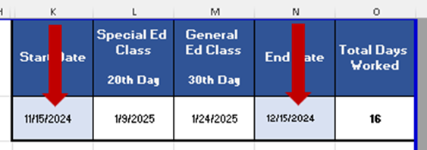

To calculate the total number of consecutive days spent in one classroom, place the first day in the   
“**Start Date**” cell (**K2)**, place the last date in the “**End Date**” cell (**N2),** cell **O2** provides the number of school days between **K2** and **N2**.

**How do I use the Cumulative Sub Assignment Monitoring Tool?**

For non-consecutive /intermittent days worked in the classroom, please put the first date in the “**Start Date**” column (**E)**, the last date in the “**End Date**” column **(F)** for each time the substitute teacher works in the same classroom, then the days worked will be counted in the “Number of Sub Days” column (**G**) and totaled for the year. Please see the example below:

* In this example, the substitute may not work in this general education classroom after March 14th because that was the 30th cumulative day served in the classroom.
* In the same example, the substitute may not work in a special education classroom after January 24th because that was the 20th cumulative day served in the classroom.

To minimize mistakes, the only cells that you may edit are those in columns **E, F, K** and **N** (those with blue shading). You may not edit any other cells.

**Why are there tabs for each month?**

Monthly calendars with notes are available to help track other details such as holidays, unassigned days, and any other relevant information.



For more information about substitute teachers or how to use the Sub Assignment Monitoring Tool, please email [SubDesk@lausd.net](mailto:SubDesk@lausd.net).