LAUSD Fundamental Skills Test

Throw and catch an object with a partner, increasing the distance

CATCH GRADE 3

**Content Standard**

**Name of assessment tool**

Catch while traveling

**Tool Description**

Facility and equipment:

* Use of an area the size of a standard Four Square box (16’ X16’) denoted by lines, chalk or cones
* Student stands at either side of the box at the center line
* Mark a line 15” away from the catcher for the tosser to stand stationary
* Bucket or container to hold 5 to 10 tennis balls placed near the tossing line
* Clipboard, recording sheet and pencil or pen ready for recording assessment
* Or – place a video device side to the student, the field of view should include the student and 1.5 to 2 body lengths above the students head

**Procedures**

Explain and demonstrate the test requirements of the catching while traveling.

* Student catching stands at either side edge of the catching area and at the mid line
* The thrower stands at a line 15’ away from the mid line and centered to the catching area
* Place a container of 10 tennis balls at the throwing line
* Tosser stands at the 15” line with the container of tennis balls and throws overhand to the catcher as they job toward the other side of the catching area
* The catcher is to jog toward the other side of the catching area in a straight line
* The thrower should lead the runner with in reason so the catcher only has to slow or speed up slightly to adjust to the ball
* The ball should be with in the catchers arm length above or below the shoulder
* They are to repeat this 5 – 10 times, if it is 5 then the recorder will double the score
* Mark the score on record document under “times caught”, if the student catches 4 out of the 5 balls correctly then you will record 8 catches.
* Record the teacher observation according to the appropriate level on the rubric
* Allow the catcher to pause and rest between catches

**Performance Criteria**

1. The catcher is able to adjust their arms and hands to the flight of the ball
2. Eyes track the ball throughout the flight to the hands
3. Hands reach to the ball
4. Hands positioned properly with the flight of the ball
5. The ball is caught and controlled with the hands until controlled

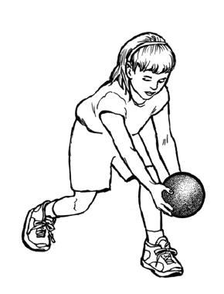 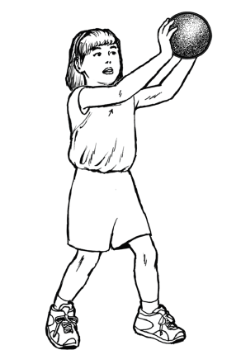

Eyes track the ball

Reach to the ball

Hands and finger positioned correctly

Controlled with hands

**Procedure**

1. Demonstrate the catch assessment
2. Have a container of 5-10 tennis balls at a 15’ mark away from the catcher
3. The tosser should be able to consistently toss leading the catcher as they jog
4. If the toss is not leading the student and an arms length away from the catchers shoulder do not count it as a toss and repeat
5. Answer any questions the student might have
6. Ask the tosser to take one ball from the container and to stand at the tossing line and wait until the student is ready or the teacher gives the command to toss
7. If the student catch’s the ball they can put it in a container outside the catching area
8. Have the catcher pause and return to the starting point until they are ready for the next toss and repeat the next toss and catch
9. If they miss the ball don’t have them chase the ball, they are to get another from the container
10. You can ask several other students to retrieve any missed balls and return them to the container
11. Repeat 5-10 times and record the catch after each attempt
12. Record only the segments of the criteria that the student does not perform
13. After all tosses tally only the catches that are 100% correct criteria and caught

Catcher starts at either side on the mid line.

Midline

X

Thrower stands at Mid Line 15 feet from Midline