LAUSD Fundamental Skills Test

Catch a gently thrown ball below the waist, reducing the impact force

CATCH GRADE 2

**Content Standard**

**Catch a gently thrown ball below the waist, reducing the impact force**

**Name of assessment tool**

Catch with proper hand position

**Tool Description**

Facility and equipment:

* Use of an area the size of a Four Square box or Circle (10’ X10’) denoted by lines, chalk or cones
* Student stands in the center of the area
* Mark a line 15” away from the catcher for the tosser to stand
* Bucket or container to hold 5 to 10 tennis balls placed at the edge of the tossing line
* Clipboard, recording sheet and pencil or pen ready for recording assessment
* Or – place a video device side to the student, the field of view should include the student and 1.5 to 2 body lengths above the students head

**Procedures**

Explain and demonstrate the test requirements of Catch with proper hand position.

* Student catching stands at the center of the assessment catching area
* Place a container for the balls outside the catching area
* Tosser stands at the 15” line with the container of tennis balls and tosses underhand to the catcher with enough arc so that the ball lands at or below the waist of the catcher with out them having to take more than one step
* They are to repeat this 5 – 10 times, if it is 5 then the recorder will double the score
* Mark the score on record document under “times caught”, if the student catches 4 out of the 5 balls correctly then you will record 8 catches.
* Record the teacher observation according to the appropriate level on the rubric

**Performance Criteria**

1. The body is positioned to align with the object by moving the feet with elbows bent and hands in front of the body as the ready position
2. Eyes track the ball throughout the flight to the hands
3. Hands reach to the ball
4. Hands positioned with little fingers close together
5. The ball is caught and controlled with the hands only until controlled
6. Elbows bend to reduce the impact of the force of the ball

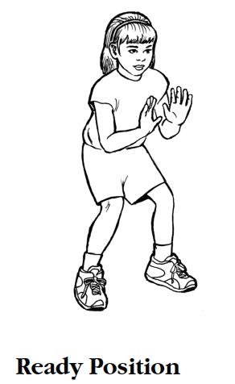 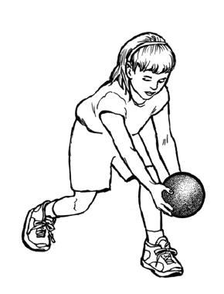

Eyes track the ball Reach to the ball Hands and finger positioned correctly

 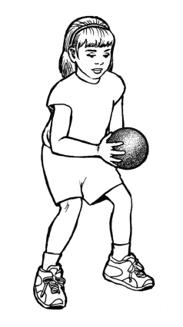

Controlled with hands Reduce the impact

**Procedure**

1. Demonstrate the catch assessment
2. Have a container of 5-10 tennis balls at a 15’ mark away from the catcher
3. The tosser should be able to consistently toss to the center of the catching area with an arc so that the ball lands at or below the catchers waist without the catcher having to take more than one step
4. If the toss is not at or below the catchers waist do not count it as a toss and repeat
5. Answer any questions the student might have
6. Ask the tosser to take one ball from the container and to stand at the tossing line and wait until the student is ready or the teacher gives the command to toss
7. If the student catch’s the ball they can put it in a container outside the catching area
8. Have the catcher pause until they are ready for the next toss and repeat the next toss and catch
9. If they miss the ball don’t have them chase the ball, they are to get another from the container
10. You can ask several other students to retrieve any missed balls and return them to the container
11. Have the catcher pause between each toss and catch
12. Repeat 5-10 times and record the catch after each attempt
13. Record only the segments of the criteria that the student does not perform
14. After all tosses tally only the catches that are 100% correct criteria and caught