LAUSD Fundamental Skills Test

CATCH GRADE 1

**Content Standard**

**Catch a self-tossed ball.**

Catch, showing proper form, a gently thrown ball.

Catch a self-bounced ball.

**Name of assessment tool**

Self toss and catch

**Tool Description**

Facility and equipment:

* Use of an area the size of a Four Square box or Circle (10’ X10’) denoted by lines, chalk or cones
* Student stands in the center of the area
* Bucket or container to hold 5 to 10 tennis balls placed at the edge of the starting area
* Clipboard, recording sheet and pencil or pen ready for recording assessment
* Or – place a video device side to the student, the field of view should include the student and 1.5 to 2 body lengths above the students head

**Procedures**

Explain and demonstrate the test requirements of the self-catch assessment.

* Students stands at the center of the assessment area
* They are to take on ball at a time and underhand toss the ball at least one or two body lengths above their head and catch the ball before it bounces
* They are to repeat this 5 – 10 times, if it is 5 then the recorder will double the score
* Mark the score on record document under “times caught”
* Record the teacher observation according to the appropriate level on the rubric

**Performance Criteria**

1. The body is positioned under the object by moving the feet with elbows bent and hands in front of the body as the ready position
2. Eyes track the ball throughout the flight to the hands
3. Hands reach to the ball
4. Hands and finger positioned correctly (around the ball)
5. The ball is caught and controlled with the hands only until controlled
6. Elbows bend to reduce the impact of the force of the ball

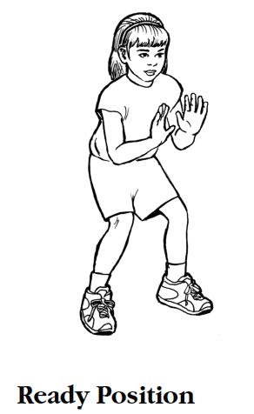 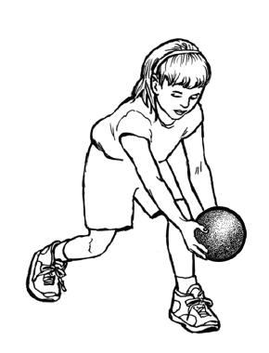 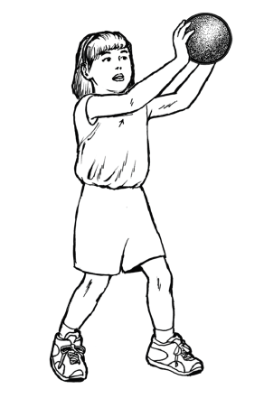 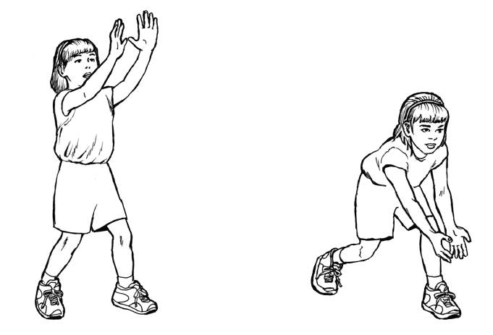

Eyes track the ball Reach to the ball Hands and finger positioned correctly

 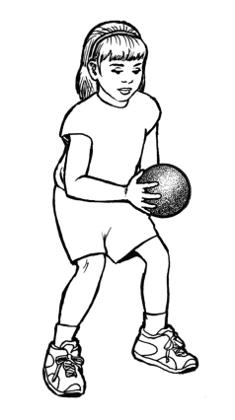

Controlled with hands Reduce the impact

**Procedure**

1. Demonstrate the catch assessment
2. Have a container of 5-10 tennis balls outside the catching area
3. Answer any questions the student might have
4. Ask the student take one ball from the container and to stand at the center of the catching area
5. Ask the student to toss the ball straight up and catch it before it hits the ground
6. If they catch it they can repeat the next toss and catch with that ball
7. If they miss the ball don’t have them chase the ball, they are to get another from the container
8. You can ask several other students to retrieve any missed balls and return them to the container
9. Have the test subject pause between each toss and catch
10. Repeat 5-10 times and record the catch after each attempt
11. Record only the segments of the criteria that the student does not perform
12. After all tosses tally only the catches that are 100% correct criteria and caught

Catching a self tossed ball

Teacher______________________________________________________Grade__________Date____/____/________

|  |  |  |  |  |  |  |  |  |  |
| --- | --- | --- | --- | --- | --- | --- | --- | --- | --- |
|  | Name |  |  |  |  |  |  |  |  |
|  |  |  |  |  |  |  |  |  |  |
|  |  |  |  |  |  |  |  |  |  |
|  |  |  |  |  |  |  |  |  |  |
|  |  |  |  |  |  |  |  |  |  |
|  |  |  |  |  |  |  |  |  |  |
|  |  |  |  |  |  |  |  |  |  |
|  |  |  |  |  |  |  |  |  |  |
|  |  |  |  |  |  |  |  |  |  |
|  |  |  |  |  |  |  |  |  |  |
|  |  |  |  |  |  |  |  |  |  |
|  |  |  |  |  |  |  |  |  |  |
|  |  |  |  |  |  |  |  |  |  |
|  |  |  |  |  |  |  |  |  |  |
|  |  |  |  |  |  |  |  |  |  |
|  |  |  |  |  |  |  |  |  |  |
|  |  |  |  |  |  |  |  |  |  |
|  |  |  |  |  |  |  |  |  |  |
|  |  |  |  |  |  |  |  |  |  |
|  |  |  |  |  |  |  |  |  |  |
|  |  |  |  |  |  |  |  |  |  |
|  |  |  |  |  |  |  |  |  |  |
|  |  |  |  |  |  |  |  |  |  |
|  |  |  |  |  |  |  |  |  |  |
|  |  |  |  |  |  |  |  |  |  |
|  |  |  |  |  |  |  |  |  |  |
|  |  |  |  |  |  |  |  |  |  |
|  |  |  |  |  |  |  |  |  |  |
|  |  |  |  |  |  |  |  |  |  |
|  |  |  |  |  |  |  |  |  |  |
|  |  |  |  |  |  |  |  |  |  |
|  |  |  |  |  |  |  |  |  |  |
|  |  |  |  |  |  |  |  |  |  |
|  |  |  |  |  |  |  |  |  |  |
|  |  |  |  |  |  |  |  |  |  |
|  |  |  |  |  |  |  |  |  |  |