Title/Author: Livingston Mouse by Pamela Duncan Edwards
Suggested Time to Spend: 5 Days (at least 20 minutes per day)
Common Core grade-level ELA/Literacy Standards: RL.1.1, RL.1.2, RL.1.3, RL.1.4, RL.1.7; W.1.1, W.1.8; SL.1.1, SL.1.2, SL.1.5, SL.1.6; L.1.1, L.1.2, L.1.4, L.1.5
Lesson Objective:
Students will listen to an illustrated narrative read aloud and use literacy skills (reading, writing, discussion and listening) to understand the central message of the text.

Teacher Instructions
Before the Lesson
- Read the Big Ideas and Key Understandings and the Synopsis below. Please do not read this to the students. This is a description to help you prepare to teach the book and be clear about what you want your children to take away from the work.
Big Ideas/Key Understandings/Focusing Question
Wild animals select habitats based on their needs of survival.
Focusing Questions: Where was Livingstone’s China? Why was it the best place for his new nest? Use pictures and words to show what the author wants us to learn about Livingstone’s journey in selecting an appropriate habitat that meets his needs. Livingstone’s best place to live was in a china teapot. It had all the things he needed. It had a place to build his nest and a way to climb in. It was also the best place for him because it didn’t have any bad smells or bright lights. Livingstone found his perfect home at last.
Synopsis
An adventurous mouse named Livingston is faced with the task of finding a place to build his own nest. At his mother’s suggestion that “China is very nice” he embarks on a journey to find the “greatest place in the world.” Encountering a variety of habitats, and meeting a number of other creatures, Livingston explores each location’s suitability through his five senses. The lesson in multiple meaning of words is emphasized when Livingston finds “China” in an old teapot.
- Go to the last page of the lesson and review “What Makes this Read-Aloud Complex.” This was created for you as part of the lesson and will give you guidance about what the lesson writers saw as the sources of complexity or key access points for this book. You will of course evaluate text complexity with your own students in mind, and make adjustments to the lesson pacing and even the suggested activities and questions.
- Read the entire book, adding your own insights to the understandings identified. Also note the stopping points for the text-inspired questions and activities. Hint: you may want to copy the questions vocabulary words and activities over onto sticky notes so they can be stuck to the right pages for each day’s questions and vocabulary work.

The Lesson – Questions, Activities, and Tasks

Questions/Activities/Vocabulary/Tasks | Expected Outcome or Response (for each)
FIRST READING:  Read aloud the entire book with minimal interruptions. Stop to provide word meanings or clarify only when you know the majority of your students will be confused.  Note: Teacher prepares 3 sets of the five location pictures (drawer, shoe, picnic basket, cage, and the lamp post) and 3 sets of the five senses cards (nose, tongue, eyes, ears, hand). It may help to color code for management based on the size of your class | The goal here is for students to enjoy the book, both writing and pictures, and to experience it as a whole. This will give them some context and sense of completion before they dive into examining the parts of the book more carefully.  Picture support for this activity attached at the end of this document. These pictures are preparation materials to be used on Day 3.
SECOND READING:  Reread page 3 and 4  QUESTIONS:  The author uses the word explorer to describe Livingston. What does Livingstone do that shows that he is an explorer?  Investigating is another way to say exploring. What is Livingstone investigating? Why?  Reread page 5  QUESTIONS:  Where does Livingstone’s mother suggest he look for a new nest? How does he react?  Look at the word “China”. What do you notice about how the author chose to write this word? Why is this important?  Activity- Sequencing the possible habitats with interactive role-play.  - Continue to read the remaining pages of the text providing the students with purpose to pay attention to the different places Livingstone considers for his nest. Draw attention to the statement that is repeated by each creature Livingstone encounters (“This isn’t China, why don’t you try that way?”)  - Allow students to read the repetitive statement with you as the text continues to the end.  - Using 5 large sheets of paper, create an interactive sequencing activity in an open area in your classroom. Choose one student to act out Livingstone’s exploration of the five possible habitats.  - Reread sections that focus on the different locations as the chosen student moves along the path created by the paper.  - Direct the rest of the class to echo the phrase “This isn’t China, why don’t you try that way?” as the chosen student moves to the next location. | He spends a lot of time running here and there.  He is investigating “this and that” such as the banana peel or other places around him.  His mother tells him that China might be nice. Livingstone seems happy or pleased. He has a smile on his face and kisses his mother good-bye. He says, “I will go to find China.”  It may be helpful to write the sentences from the text that have the word “China” in them. Draw students’ attention to the word by prompting with, “What do you notice about how the first letter of this word looks?” Guide students in understanding that the author capitalized the word China because it is a place or country.  This is a kinesthetic activity that helps the students retell the events or locations that have been explored in the text.  Check to see that students are able to recall each location that Livingstone visited as the selected student moves along each of the different places.  Sample student participation:  Teacher: Where did Livingstone go first? What is he told?  Students: He went to the drawer and he is told “This isn’t China. Why don’t you try that way?”  drawer  shoe  basket  cage  lamp post

THIRD READING:  Explain that today we will read the text again to investigate why Livingstone continues to search for the “greatest place” to make his nest. Read pages 3-5 without stopping.  Now turn and talk to your elbow partner.  Why is Livingstone investigating/exploring different habitats for his nest?  Reread pages 6-8:  QUESTIONS:  Where does he go to first?  What word does Livingstone use to talk about this habit?  What did Livingstone think was “incredible” about this habitat?  What creature does Livingstone meet?  Why is it called a “click beetle”?  Reread page 9:  QUESTIONS:  What do you think “argumentative” means?  Why does the author call the cockroaches “argumentative”?  Why does Livingstone keep searching? What does Livingstone need in a home?  Reread pages 10-11  QUESTIONS:  Listen carefully to the words the author uses to talk about the next place Livingstone goes.  Where does he go next?  What are the words “rope ladder” describing?  What word does Livingstone use to talk about this habitat?  Reread pages 12-13:  QUESTIONS:  What did Livingstone think was “fantastic” about this habitat?  Why does he keep searching?  Reread pages 14-15  QUESTIONS:  Where does he go next?  What do you think “peculiar” means?  Why do you think the author describes the objects as “peculiar”?  What word does Livingstone use to talk about this habitat?  Reread pages 16-17:  QUESTIONS:  What did Livingstone think was “wonderful” about this habit?  Why does he keep searching?  Reread pages 18-21:  QUESTIONS:  Where does he go next?  What word does Livingstone use to talk about this habitat?  What did Livingstone think was “neat” about this habitat?  Why does he keep searching?  Reread pages 22-23:  QUESTIONS:  Where does he go next?  What word does Livingstone use to describe this habitat?  Reread pages 24-25:  What did Livingstone think was “amazing” about this habitat?  Why does he keep searching?  Activity: Mix-Freeze-Match (refer to Kagan strategies)  - Pass out cards prepared on Day 1 with locations and senses. Students find a partner to share content of their card and then they exchange cards. Students find a new partner and continue to repeat the process until the teacher says “FREEZE”.  - Students have to find their matching partner by card color and kind (location matching sense behind the reason for continuing the search. i.e. drawer - ear).  - Students need to sit with partner and using complete sentences, state how cards are a match and why.  - Bring the whole class back together and pose the questions:  - What places does Livingston consider for a habitat?  - Why does he continue to search?  - What does Livingstone need in a new home?  - Record a class response chart to capture the information. | Allow for students to “think aloud” during this time with any questions or thoughts that they have about the story up until this point.  Monitor and encourage students to speak to each other in complete sentences and use the vocabulary terms that they have learned.  Sample Student dialogue: Livingstone is exploring to find a new nest because his mom said hers was too small. Also, he is an explorer and explorers are always looking for a “better” place.  He goes to a place with a lot of drawers he thinks is a big building.  He uses the word “incredible.” He thought it was incredible because it was already divided into nest and it has lots of room.  Livingstone meets a click beetle.  It is called a click beetle because it makes a loud clicking noise.  Draw students’ attention to the verb (yelled) that the author is using to describe how the cockroaches are speaking to each other.  Possible Student responses: Argumentative might mean disagree or yell at each other. The author calls them argumentative because they are yelling at each other and complaining.  Livingstone needs a place to build a nest, a way to climb, and he needs a home that is quiet.  Some students may notice that the author describes this place similar to a mountain (tall, rising, slopes).  Livingstone finds a shoe.  Rope ladders are the shoe laces.  Livingstone uses the word “fantastic” to talk about this place.  He thought the shoe was fantastic because it was nice and quiet. Also, it had a rope ladder that he likes to climb.  He keeps searching because of the smell. It smelled nasty and musty.  He discovers a basket.  Peculiar might mean strange. The objects might be peculiar because he is looking at things he might not have seen before.  Livingstone uses the word “wonderful” to talk about the basket.  He thought it was wonderful because it’s quiet and it smelled nice.  He keeps searching because he thinks the food is too hot.  Students should use the picture and words to infer that it is a cage that Livingstone goes to next.  He uses the word “neat” to describe the cage. He thinks it is neat because it is quiet, it doesn’t smell, and the food looks like the type of food he would eat.  He keeps searching because he got hurt.  Livingstone goes outside and finds a lamp post.  He describes it as “amazing” because it looks like a perfect little house for a mouse.  He thought it was amazing because it was quiet, didn’t smell, no bad food, and nothing to hurt him.  He keeps searching because the light was too bright for him.  Picture cards to support this activity can be found at the end of this lesson. This activity encourages active participation and an opportunity for students to independently recall the relationship between the different habitats and the sensory reasons that Livingstone uses to continue his search. Encourage students to speak in complete sentences, use newly acquired vocabulary, and provide feedback to each other as agents of their own learning.  As the activity concludes, provide closure by recording the responses to the two questions in a class response chart.  See sample graphic organizer in Teacher Notes. Possible responses:
  What places does Livingstone consider for a habitat? | Why does he continue to search? | What does Livingstone need in a new home?
  A drawer | It is too noisy. | A place for a nest
FOURTH READING:
Compliment students on how carefully they have been reading the book and explain that today we will continue to look deeper into the text to discover Livingstone’s suitable or best habitat.
Reread up to page26 without stopping, inviting students to participate by phrasing the repetitive phrase “This isn’t China, why don’t you try that way?”

Then, ask a few students to briefly summarize the places Livingstone considered for his home. What does this tell us about what Livingstone needs in a home? Select additional students to orally state the reason why he continued or rejected each habitat. Stress the use of complete sentences and provide the class notes (graphic organizer) as a point of reference for the students. Provide time for all students in small groups to summarize based on the modeling.
Reread page 26:  Give the following directions:  Listen carefully to the words the author uses to describe how Livingstone feels at this point in his investigation.  QUESTIONS:  What word does the author use to describe how Livingstone’s tongue feels?  What do you think “smarted” means?  Why does Livingstone “Wearily, set off again.”?  Reread page 27:  Pay attention to the words and pictures that the author uses to talk about the last habitat.  What do you think this is?  What word does Livingstone use to talk about this habitat?  Reread pages 28:  What does the bat tell Livingstone that is different from the other creatures he meets?  Look at the word “china”. What do you notice about how the author changes how he writes the word this time?  Why is this important?  Reread pages 29-31:  Look at the picture on pages 30-31. What do you think makes this “china” the best habitat for Livingstone? | Some students may notice the use of negative describing words that the author uses to talk about what Livingstone has gone through during his exploration. It may be helpful to point, underline, highlight such words as “poor”, “sick”, and “bad” so that all students will understand how Livingstone might be feeling.  He uses the word smarted.  Some students may need to reread page 17 to understand what the author means. Listen for answers that show an understanding that it means something similar to “hurt” or “burned”.  He still had not found China or the perfect place to build his new nest.  It may be helpful to have an actual teapot as a reference point and to point to the objects in the picture that the author is describing.  It is a teapot.  He says it is the greatest.  The bat is different from the other animals because he tells Livingstone that it is some old china.  Allow a minute for students to think. It may be helpful to refer back to the previous sentence strips that called out the word China early on it the text. Guide them in discovering that now the word is not capitalized.  Explain to students that sometimes words in a story mean something different than thought. Here, “china” is an object (teapot) that is made out of a sort of breakable material called china.  Students’ answers may vary. Teacher should take them back to the text or anchor chart for the evidence and reasons. All students’ writing should be able to include if using the anchor chart is modeled.

FINAL DAY WITH THE BOOK - Culminating Task
- Where was Livingstone’s China? Why was it the best place for his new nest? Use pictures and words to show what the author wants us to learn about Livingstone’s journey in selecting an appropriate habitat that meets his needs.
- Sample answer: Livingstone’s best place to live was in a china teapot. It had all the things he needed. It had a place to build his nest and a way to climb in. It was also the best place for him because it didn’t have any bad smells or bright lights. Livingstone found his perfect home at last.

Vocabulary
These words merit less time and attention  (They are concrete and easy to explain, or describe events/  processes/ideas/concepts/experiences that are familiar to your students ) | These words merit more time and attention  (They are abstract, have multiple meanings, and/or are a part  of a large family of words with related meanings. These words are likely to describe events, ideas, processes or experiences that most of your student will be unfamiliar with)
Page 8- murmured  Page 11- scampered  Page 13 - chittered  Page 18-plodded  Page 28-china  Page 4-nest | Page 3 - explorer  Page 4 - investigating  Page 15- peculiar  Page 9-argumentative  Page 26-smarted  Page 26-wearily

Fun Extension Activities for this book and other useful Resources
Dramatic Play
- Have students assume the roles of the different animals and act out the sequence of events.
Investigating Habitats
- Have students identify the different animals in the story and investigate the habitats that they would like
Exploring the Five Senses
- Read the book My Five Senses by Aliki and discuss what they heard.
- Have the children view the video of the story being read as a different way to use their senses to understand the text http://www.watchknowlearn.org/Video.aspx?VideoID=34065&CategoryID=9452

Note to Teacher
- Below is a sample of a completed class chart of “class notes”. In this type of group note taking, the teacher helps the class to decide what to record. Notes can take the form of words, quick drawings, clip art, or any combination of the three. Notes may be paraphrased or quoted. Having students paraphrase can encourage the use of newly acquired vocabulary. Students should be referring to the notes frequently as a tool to reinforce knowledge building about the text.

What places does Livingstone consider as a new habitat?
What places does Livingstone consider as a new habitat? | Why does he continue to search? | What does Livingston need in a new home?
A drawer that looks like a building | It was too noisy. | A place to build a nest, raise little ones
A shoe | It was smelly. | A way to climb in and out
A picnic basket | The food was bad. | A way to get food
A cage or square room | It was dangerous and he got hurt.
A lamp post | It was too bright.


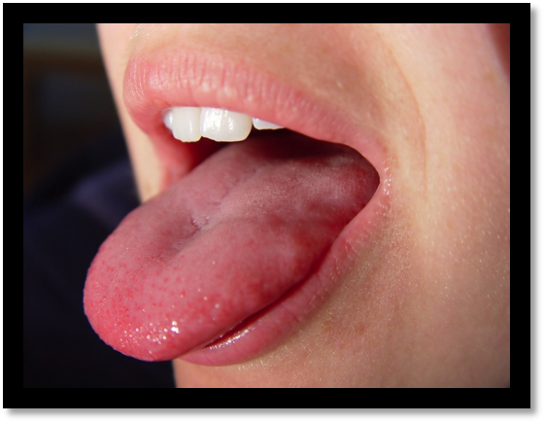

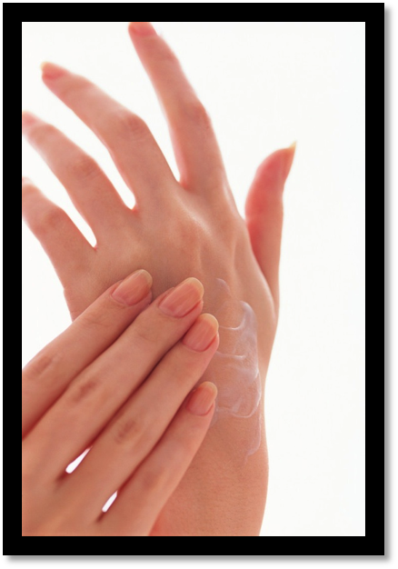

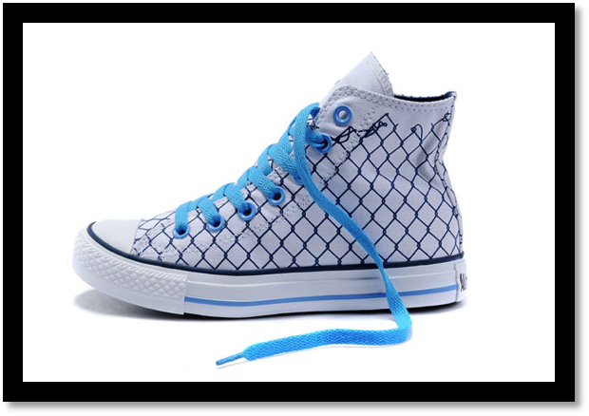


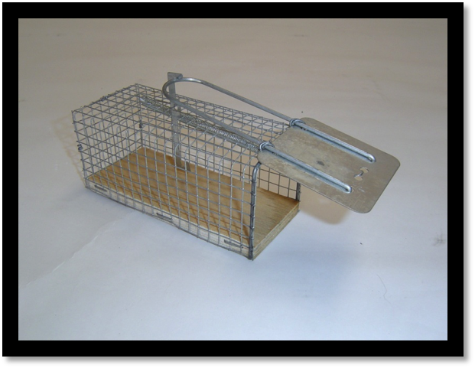
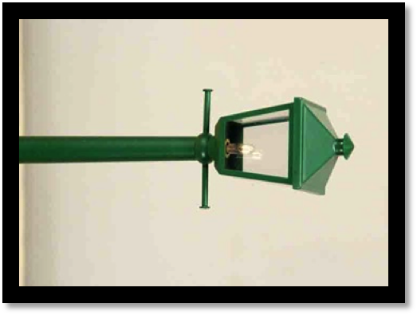

What Makes This Read-Aloud Complex?
- Quantitative Measure
Go to http://www.lexile.com/ and enter the title of your read-aloud in the Quick Book Search in the upper right of home page. Most texts will have a Lexile measure in this database.

510
Most of the texts that we read aloud in K-2 should be in the 2-3 or 4-5 band, more complex than the students can read themselves.
2-3 band 420-820L
4-5 band 740-1010L

- Qualitative Features
Consider the four dimensions of text complexity below. For each dimension*, note specific examples from the text that make it more or less complex.
Words with Multiple Meanings-China vs. China
Appropriate habitat to meet the needs of a mouse-note about what he needed to build nest, five senses being offended (too noisy, too smelly, too bright)
Dialogue between animals and Livingstone
Repetition in redirecting Livingstone
Complex sentence structure
Figurative Language-“Up one of its slopes ran a
Rope ladder.” “his tongue smarted”
Descriptive language of animal movement-scurried, skittered. Chittered, plodded
Animal names-luna moth, camel cricket, click beetle

Some students may need background on what an explorer does
Information about China as a geographical location and a material for dishes.
Suitable habitats for mice.

Meaning/Purpose
Structure

Language
Knowledge Demands

- Reader and Task Considerations
What will challenge my students most in this text? What supports can I provide?
Multiple meanings of words and descriptive language. Repeated readings and questions to clarify vocabulary meaning. Additional text to, both fiction and non-fiction to provide support about this topic.

How will this text help my students build knowledge about the world?
Scientific building of knowledge about the needs of a mouse in selecting a habitat. Academic vocabulary will be built systematically through the multiple readings that they may encounter later.

- Grade level
What grade does this book best belong in? 1

