Title/Author: Bats by Gail Gibbons
Suggested Time to Spend: 4-5 Days (Recommendation: two sessions per day, at least 20 minutes per day)
Common Core grade-level ELA/Literacy Standards: RI.K.1, RI.K.2, RI.K.3, RI.K.4, RI.K.7; W.K.2, W.K.8, SL.K.1, SL.K.2, SL.K.5, SL.K.6, L.K.1, L.K.2, L.K.4, L.K.5
Lesson Objective:
Students will listen to an informational piece to complement the lesson on Stellaluna by Janell Cannon. Students will use their skills (reading, writing, discussion, listening) with attention to text-features, vocabulary, and the nature of our world.

Teacher Instructions
Before the Lesson
- Read the Big Ideas and Key Understandings and the Synopsis below. Please do not read this to the students. This is a description to help you prepare to teach the book and be clear about what you want your children to take away from the work.
Big Ideas/Key Understandings/Focusing Question
How does the author show us how bats are helpful to our world? Bats are able to help pollinate flowers, control the insects, and contribute to our world.
Synopsis
Even though most people have never seen a real bat, many find them scary. In reality, bats are shy, gentle animals. There are about 1,000 different kinds of bats, and they live on every continent except Antarctica. Some are tiny, like the hog-nose bat, that weighs less than one fourteenth of an ounce. Others are large, such as the giant flying fox with its five-foot wingspan. This informative book by Gail Gibbons offers an intriguing look at some of the many different kinds of bats, their amazing abilities, and how these mammals fit into the natural world.
- Go to the last page of the lesson and review “What Makes this Read-Aloud Complex.” This was created for you as part of the lesson and will give you guidance about what the lesson writers saw as the sources of complexity or key access points for this book. You will of course evaluate text complexity with your own students in mind, and make adjustments to the lesson pacing and even the suggested activities and questions.
- Read the entire book, adding your own insights to the understandings identified. Also note the stopping points for the text-inspired questions and activities. Hint: you may want to copy the questions vocabulary words and activities over onto sticky notes so they can be stuck to the right pages for each day’s questions and vocabulary work.

The Lesson – Questions, Activities, and Tasks

Questions/Activities/Vocabulary/Tasks | Expected Outcome or Response (for each)
FIRST READING:  Read aloud the entire book (or chapter) with minimal interruptions. Stop to provide word meanings or clarify only when you know the majority of your students will be confused. | The goal here is for students to enjoy the book, both writing and pictures, and to experience it as a whole. This will give them some context and sense of completion before they dive into examining the parts of the book more carefully. Also, during this read, we will be working with new vocabulary, so that students are familiar with terms used to better understand the information.  Students will make their bat puppet. See handout on page 15.
SECOND READING:  1. During this reading, the teacher should elaborate with gestures and voice to build vocabulary concepts. Create an anchor chart with words and drawings that will allow students to refer back to the words during multiple reads.  The chart will include: swoop, swerve, dive, shy, gentle, scary, rapid, clings, clutches, and protect.  Teacher will model the terms as she reads aloud.  Page 2 - dive…to travel down through the air to a lower level  Page 2 - swoop…moves suddenly down through the air, especially in order to attack something  Page 2 - swerve…to make a sudden sideways movement while moving forwards, usually in order to avoid hitting something  Page 5 - shy…nervous and embarrassed about meeting and speaking to other people, especially people you do not know  Page 5 - gentle-kind and careful in the way you behave or do things, so that you do not hurt or damage anyone or anything  Page 5 - mammals… After reading the page add that mammals also drink milk from their mother. Show students the students the visual Types of Mammals on page 16.  Page 6 - fossil…fossils are bones of animals that were alive a long time ago  Page 6… ears, eyes, nose, body, tail, foot, and wings  Page 11 - nooks and crannies…The teacher uses their bat puppet to show the bat going inside a desk. The inside of your desk is like a nook and cranny. It is small and dark. (Fast mapping this word does not add to students’ content knowledge of bats, but is a good connection to idiomatic expressions.)  Page 11 - roosts …a place where birds or bats rest and sleep  Page 11 and 12 Teacher tells students that in November December, January, February, and part of March are the winter months. This is when the bat hibernates or sleeps. The end of March is when spring begins and the bats wake up.  Page 14 wingspan… Show students with the teacher bat puppet how to measure the wingspan of a bat. Have students show where they would measure the wingspan on their puppet. (Again, teacher is fast mapping terms that students may need to hear explained to understand the information in this text.)  Page 14 one-fourteenth of an ounce and two pounds…  Teacher shows students two paperclips and two cans of soup. Two paperclips weigh about the same as the weight of Kitti’s hog-nosed bat. The two soup cans are the weight of the Giant Flying Fox. This is a demonstration of the size comparisons between the Giant Flying Fox and Kitti’s hog-nosed bat. (Teacher is using realia to cement the connection between the reading and real life objects.)  Page 15 – echolocation…the location of objects by reflected sound, in particular that used by animals such as dolphins and bats  Page 15 – rapid…happening or done very quickly and in a very short time  Page 16 - echoes…if a sound echoes, you hear it again because it was made near something such as a wall or hill: if a place echoes  Page 16 - bounce…if a ball or other object bounces, or you bounce it, it immediately moves up or away from a surface after hitting it repeated or are similar to each other  Page 16 - scoops…pick up and move (something) with a scoop  Page 17 - scatter…if someone scatters a lot of things, or if they scatter, they are thrown or dropped over a wide area  Page 18 – smooth…a smooth surface has no rough parts, lumps, or holes, especially in a way that is pleasant and attractive to touch  Page 18 – sharp…having a very thin edge or point that can cut things easily, this is like a knife  Page 18 – crushing…to press something so hard that it breaks or is damaged:  Page 19 – barely…only with great difficulty or effort  Page 20 – untrue…not based on facts that are correct  Page 20 – fictional…fictional people, events etc are imaginary and from a book or story  Page 20 – frequently…very often or many times  Page 21 – narrow…measuring only a small distance from one side to the other, especially in relation to the length  Page 22 - sense…one of the five natural physical ways you experience the world around you---seeing, hearing, tasting, touching, smelling  Page 23 – nurseries…a room in a hospital where babies that have just been born are looked after  Page 23 - pups…a young bat or dog  Page 24 – basket…a container made of thin pieces of plastic, wire, or wood woven together, used to carry things or put things in  Page 25 – cradled…hold gently and protectively  Page 25 – clings…to hold someone or something tightly, especially because you do not feel safe  Ask students to raise their hand if they recall grabbing their parents leg and wrapping their arms around them when they were scared. That is clinging to your parent’s leg. Have students cling their puppet.  Page 26 – heavy…weighing a lot  Page 26 – hunting…chasing and killing animals for food or sport  Page 27 – populations…the number of people living in a particular area, country etc.  Page 27 – habitats…the natural home of a plant or animal:  Page 27 – pollution… the process of making air, water, soil etc dangerously dirty and not suitable for people to use, or the state of being dangerously dirty:  Page 27 - crop…damaging-harming plants that will be used for food  Page 28 – pests…a small animal or insect that destroys crops or food supplies  Page 29 – provide…to give something to someone or make it available to them, because they need it or want it  Page 29 - preserves…to save something or someone from being harmed or destroyed  Page 29 – protect…to keep someone or something safe from harm, damage, or illness  Page 29 – entrances…a door, gate etc. that you go through to enter a place  Page 29 – grillwork…metal bars or wires arranged to block an opening | The goal of this reading is to have the students practice the vocabulary using total physical response and real life objects. Have students repeat the word and demonstrate its meaning through the use of gestures with their bat puppets, and recalling a sentence from the text using the vocabulary, or making up their own sentence using the vocabulary.  Students will repeat the words as they act out dive, swoop, and swerve with their bat puppets to show how they fly at night. They will also describe to their partner what the bats are doing  Students will use their puppet to show the meaning of shy, and describe to their partner how the bat is acting.  Students will use their puppet to show how to be gentle and use the word gentle in a sentence about the mother bat.  (After this reading, students may use the diagram on page 6 to complete the additional activity on page 18.)  Students will describe to a partner the many places bats might live, or roost. Sentence Frame may be used: Bats live or roost in __________. Another roost for bats is ________.  Students will have their bats and pretend to hibernate as the teacher calls out the months of the year to show when they begin to hibernate and when they wake up to fly and eat.  Students will handle the materials and Partner A will tell Partner B about the Kitti’s hog-nosed bat. Partner B will tell Partner A about the Giant Flying Fox.  Students fly their bats quickly in front of them to show the meaning of rapidly  Bounce a ball to demonstrate the meaning  Teacher uses hands to demonstrate scooping up a pile of paperclips or other objects from the class  Have students rub the back of their hand across their cheek to feel a smooth surface  Students will use hands to demonstrate what narrow looks like compared to wide  Students cradle their puppet like it was a baby  Have students partner up and use the following oral language frame to name a pest. Partner A will tell partner B, One pest I know is _________. Partner B will tell partner A, Another pest I know is __________________.  Have students point to the entrance of the classroom.
THIRD READING:  - Before reading today, we are going to watch a video on things that make bats unique.  http://video.nationalgeographic.com/video/kids/animals-pets-kids/wild-detectives-kids/wd-ep9-bats/  While watching the video, students should be listening for facts about bats. After watching, you should have students share 1-2 facts with their partners.  - We are going to reread some of the pages in Bats to see what text features this book has. Nonfiction has pictures, illustrations with labels, diagrams, and photographs.  What text features does Bats have that is important to use? Let’s make an anchor chart of the text features in this book and how they are used in this book. Read pgs. 6-8. What text features are there? How do the labels on the illustrations help us with the text?  Read pages 11-12, and 15-16. How do the illustrations help us understand facts about bats on those pages?  Read pages 23-26. How do the illustrations help us understand what bats do to take care of their babies?  Use the student journal pages on pages 19-21 as a way for students to share how specific text features allow them to recall information from the text.  - Now that we can find how the text and the illustrations help us understand the information, we are going to find out some things that bats do to help people. First let’s read page 15 and 16. Why is it important for bats to be able to catch insects?  If there are too many insects, what might happen?  Continue discussing with students the facts on pages 27-28, and 31. Connect the reading on 31 with the information on 27 and 28 about insects. Draw students’ attention to the first and the last facts on page 31 to make the connection. Teacher will provide support for students to answer the question “Why is it important for bats to be able to catch insects?” by rereading the text on those pages..  Does that mean that bats are important to people and to our environment? Let’s think about that. | - Students should know that bats are the only mammal who can fly without an airplane. They love fruit and insects. They live in the dark. They are important to the environment, and they emit a sound that bounces off objects, so they can find them in the dark.  - Students will work with a partner to answer teacher questions. Labels on the illustration help us find all the parts of a bat.  The illustrations add extra facts and show us what the words mean.  The illustrations show us how the mother bat holds her baby and how she keeps it safely with her when she is flying.  - Students will discuss with partners and be able to describe from the text: The book says, “If it weren’t for bats, there would be too many insects.”  The insects would eat too many plants, and the plants would die.
FOURTH AND BEYOND:  Before we begin our lesson today, let’s review what we learned yesterday.  Today we want to talk about all the ways that bats can help people. We are going to write these facts down or draw a sketch so that we don’t forget. We are going to label our sketches with words we need to use in writing about the facts we learned.(see additional resources)  Let’s read page 17 and look at the small picture in the corner. “These bats help pollinate plants so we can have foods such as avocados, figs and bananas. They also help scatter seeds.” This word pollinate is on our vocabulary chart, but the text isn’t helping me know what it means. Let’s see if the little picture in the corner helps. That picture is of the parts of a flower. “Pollination happens when a grain of pollen of a stamen lands on the stigma of another flower like itself. “ Here I have 2 real flowers. We are going to match the parts of the flower to the picture. The stigma is deep inside the flower. A stamen from a different flower has to go deep inside the flower petals to land on the stigma. In the picture a little bat is drinking from a flower. He can catch the stamen on his fur or nose, and when he gets another drink, will touch the stamen to a new flower. How does this help people?  The next sentence says, “They also help scatter seeds.” How do bats help people by scattering seeds?  Now we know how important bats are to our environment, what does the author say that we should do to protect them. Reread page 29. | Students will use the following language frame…Partner A: One thing I learned about Bats yesterday was……  Partner B: Something I learned about Bats yesterday was….  Students will discuss and be able to find in the text: It will make new plants like figs, bananas, and other plants. (Students will tell teacher what to sketch or write.)  When bats drink from the flower, their nose gets pollen on it. When they drink from a different flower, the pollen falls off onto that flower.  Scattering seeds will help make new plants. This helps people because we need plants for food and air.  Students will tell a partner what the author wants us to do.  Students should respond: a) bat houses where they can roost; b) make cave entrances covered so that people can’t get in; and c) make places where large groups of bats can live without people touching them or hurting them.

FINAL DAY WITH THE BOOK - Culminating Task
- Teachers will review the sketches and sentences created with students on all the ways bats help the environment and review the discussions students had based on the illustrations about pollinating flowers, eating insects, etc. from the text. Then students will complete the following activity.
  - Draw a picture showing one way bats are able to help people in our world. Use the words and labels on our sketched notes to help you finish your sentence frame.
  - Sample responses for student writing could be:
    - one-word responses that describe what the bat is doing in the drawing,
    - a phrase that completes the sentence frame, or
    - an additional sentence describe how bats are able to help people. We would be flexible with the writing in this task based on the time of the year that students are working with this book, and the writing instruction students have been exposed to at this time.

Name: _______________________________
Draw a picture showing one way these animals are able to help people in our world. Use the words from our vocabulary chart to help you finish your sentence frame.

These animals are important to our world because ___________________________
________________________________________________________________.
Name: _______________________________
Draw a picture showing one way these animals are able to help people in our world. Write a sentence using the words from our vocabulary chart to help you tell why these animals are important to our world.

________________________________________________________________
________________________________________________________________.
Vocabulary
These words merit less time and attention  (They are concrete and easy to explain, or describe events/  processes/ideas/concepts/experiences that are familiar to your students ) | These words merit more time and attention  (They are abstract, have multiple meanings, and/or are a part  of a large family of words with related meanings. These words are likely to describe events, ideas, processes or experiences that most of your student will be unfamiliar with)
Page 2- dive- to travel down through the air to a lower level  Page 2- swoop- moves suddenly down through the air, especially in order to attack something  Page 2- swerve- to make a sudden sideways movement while moving forwards, usually in order to avoid hitting something  Page 3- Important- of great value or means a lot  Page 4- scary-frightening  Page 5- shy- nervous and embarrassed about meeting and speaking to other people, especially people you do not know  Page 5- gentle-kind and careful in the way you behave or do things, so that you do not hurt or damage anyone or anything  Page 5 nooks and crannies- small, out of the way place where something can be hidden  Page 15- rapid-happening or done very quickly and in a very short time  Page 16- bounce-if a ball or other object bounces, or you bounce it, it immediately moves up or away from a surface after hitting it  Page 17- scatter-if someone scatters a lot of things, or if they scatter, they are thrown or dropped over a wide area  Page 18- smooth-a smooth surface has no rough parts, lumps, or holes, especially in a way that is pleasant and attractive to touch  Page 18- sharp-having a very thin edge or point that can cut things easily  Page 18- crushing-to press something so hard that it breaks or is damaged:  Page 19- barely-only with great difficulty or effort  Page 20- frequently-very often or many times  Page 21- narrow-measuring only a small distance from one side to the other, especially in relation to the length  Page 22- sense-  Page 23- nurseries-a room in a hospital where babies that have just been born are looked after  Page 23- pups-a young bat or dog  Page 25- cradled-hold gently and protectively  Page 25- clings-to hold someone or something tightly, especially because you do not feel safe  Page 26- heavy-weighing a lot  Page 26- hunting-chasing and killing animals for food or sport  Page 28- pests-a small animal or insect that destroys crops or food supplies  Page 29- protect-to keep someone or something safe from harm, damage, or illness  Page 29- entrances-a door, gate etc. that you go through to enter a place  Page 29- grillwork-metal bars or wires arranged to block an opening | Page 2- Nocturnal-active at night  Page 5- mammals-a type of animal that drinks milk from its mother's body when it is young. Humans, dogs, and whales are mammals.  Page 7- membrane-a very thin piece of skin that covers or connects parts of your body  Page 11- migrate-if birds or animals migrate, they travel regularly from one part of the world to another  Page 11- roosts-a place where birds or bats rest and sleep  Page 11- hibernate-if an animal hibernates, it sleeps for the whole winter  Page 15- echolocation-the location of objects by reflected sound, in particular that used by animals such as dolphins and bats  Page 16- echoes-if a sound echoes, you hear it again because it was made near something such as a wall or hill: if a place echoes, it is filled with sounds that are repeated or are similar to each other  Page 16- scoops-pick up and move (something) with a scoop  Page 20- untrue-not based on facts that are correct  Page 20- fictional-fictional people, events etc are imaginary and from a book or story  Page 24- basket-a container made of thin pieces of plastic, wire, or wood woven together, used to carry things or put things in  Page 27- populations-the number of people living in a particular area, country etc  Page 27- habitats- the natural home of a plant or animal:  Page 27-pollution- the process of making air, water, soil etc dangerously dirty and not suitable for people to use, or the state of being dangerously dirty:  Page 27-pesticides-a chemical substance used to kill insects and small animals that destroy crops  Page 28- pollinate-to give a flower or plant pollen so that it can produce seeds  Page 29- provide-to give something to someone or make it available to them, because they need it or want it  Page 27- crop-damaging- harming plants that will be used for food  Page 29- preserves-to save something or someone from being harmed or destroyed

Fun Extension Activities for this book and other useful Resources
- http://animals.sandiegozoo.org/animals/bat
  - This website provides additional information on bats and their habits
- http://www.surfnetkids.com/video/818/jumpstart-bat-echolocation-song/
  - This video is a great demonstration of echolocation using cartoon character bats and a great rhyming lyric.
- http://www.readworks.org/sites/default/files/bundles/lessons-gradek-genre-studies-informational-texts.pdf
  - The readworks.org site has a number of connected writing ideas to help students process informational text.

Note to Teacher
- Making a vocabulary chart with pictures and definitions that students can refer to as you are reading both Stellaluna and Bats would be a great activity. It will also fit nicely into a literacy station where students can play “Memory” with the pictures and words.
- Another idea would be to connect how mother bats tend their pups until they learn to fly with Stellaluna and her mother. Use the vocabulary from both books: clutching, cradling, clinging, sniffing the baby’s fur (p.22), to help students connect the informational text to the story.

Name: _______________________________
Draw a picture of one fact you learned about bats.

Name: _______________________________
Draw a picture of one fact you learned from a photograph.

Name: _______________________________
Draw one fact that you learned from a diagram in the book.

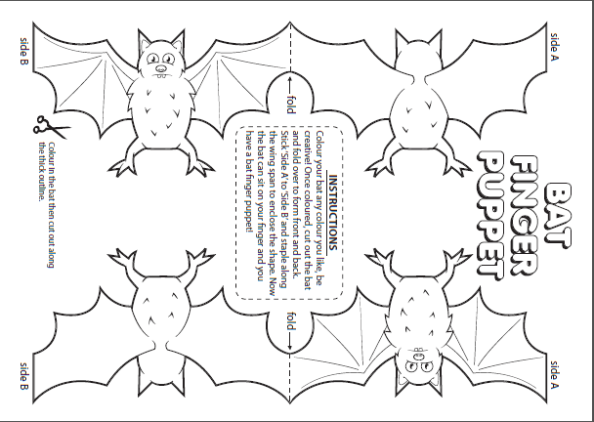
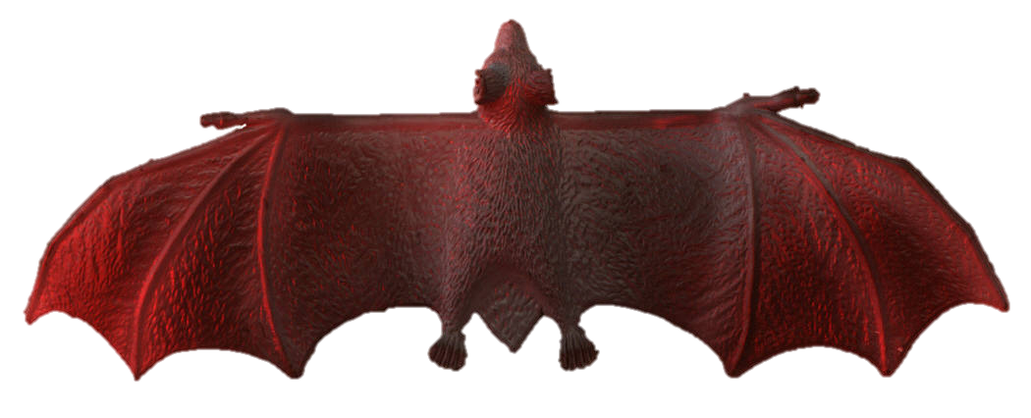
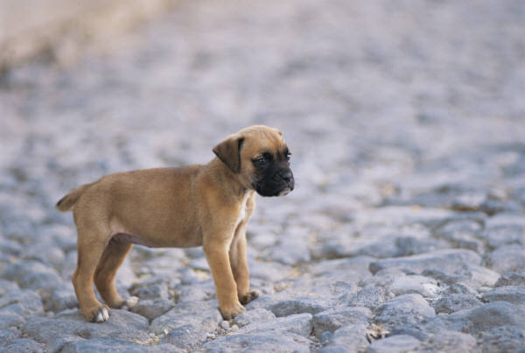
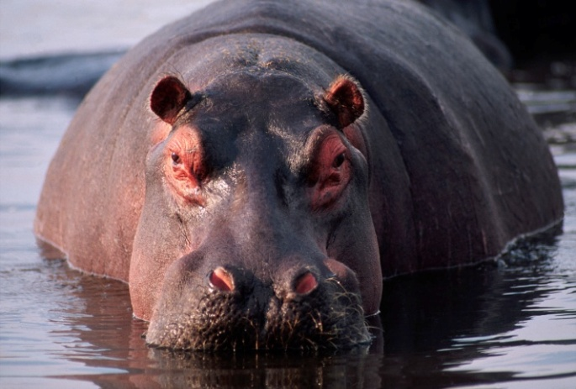
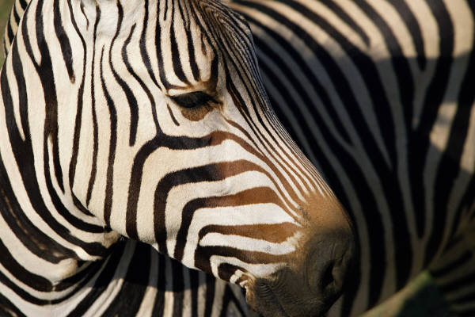
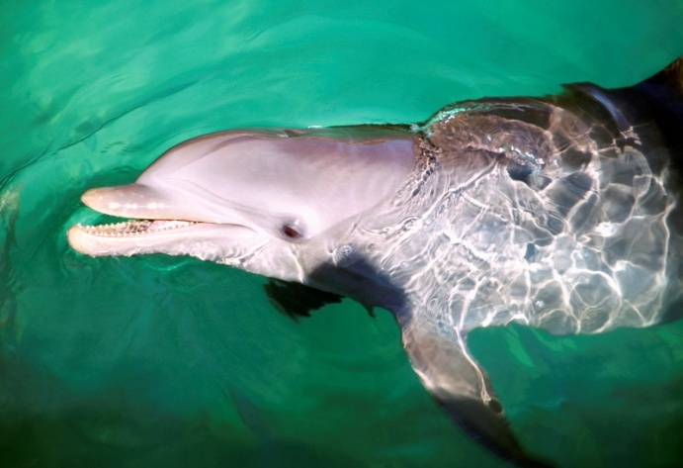
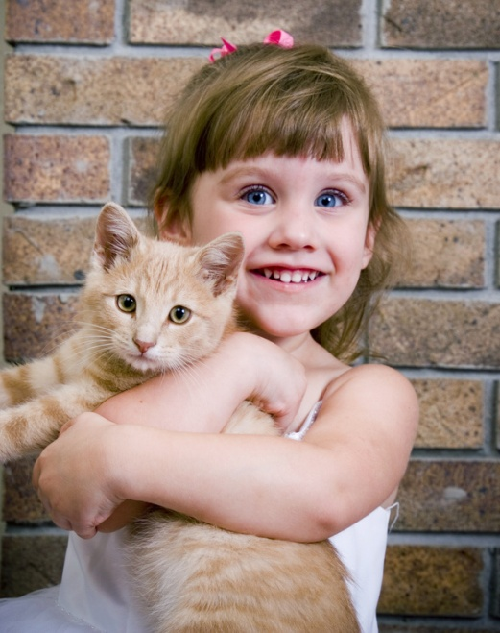
Types of Mammals
Bat
Dog
Hippo
Zebra
Dolphinn
Whale
Human
Cat
What Makes This Read-Aloud Complex?
- Quantitative Measure
Go to http://www.lexile.com/ and enter the title of your read-aloud in the Quick Book Search in the upper right of home page. Most texts will have a Lexile measure in this database.

___750L_____
Most of the texts that we read aloud in K-2 should be in the 2-3 or 4-5 band, more complex than the students can read themselves.
2-3 band 420-820L
4-5 band 740-1010L

- Qualitative Features
Consider the four dimensions of text complexity below. For each dimension*, note specific examples from the text that make it more or less complex.
The author wants you to know information about bats that makes them important to the environment, but not scary creatures.
Informational text structure: captions, pictures
Organization---informational text; although the book jumps around a bit, giving a lot of different information about the topic, bats.

Vocabulary
Sentence length and complexity

Students need background knowledge that differs from Halloween experiences with Dracula, scary movies, and costumes.

Meaning/Purpose
Structure

Language
Knowledge Demands

- Reader and Task Considerations
What will challenge my students most in this text? What supports can I provide?
- The illustrations which are so similar to story illustrations will create a difficult comparison between facts and fantasy for young students. As teachers, we need to show children how the illustrations on the pages, with diagrams or captions, enhance the factual text and the text to picture match is a characteristic of informational text. Teaching the features of informational text will also scaffold this learning.
- Using the Elmo, or document camera, teachers could zoom in to specific portions of a page in order to draw students’ attention to the features or facts that teacher is reading. The vocabulary in this book will make it difficult for kindergarten students to understand the connections and the information in the text. It is important to make sure students understand the vocabulary using both the illustrations in the book and the bat puppets for the concrete experiences.

How will this text help my students build knowledge about the world?
- Bats will help students build knowledge of how we can protect an endangered animal species.
- It also builds knowledge about the world around us by showing how bats contribute to the growth of plants, and pollination of flowers, and help keep the insect population controlled. Without bats, our vegetation would be overrun by insect pests and our plants would die.

- Grade level
What grade does this book best belong in?
- Kindergarten

