**LIST OF COMMON ERRORS**

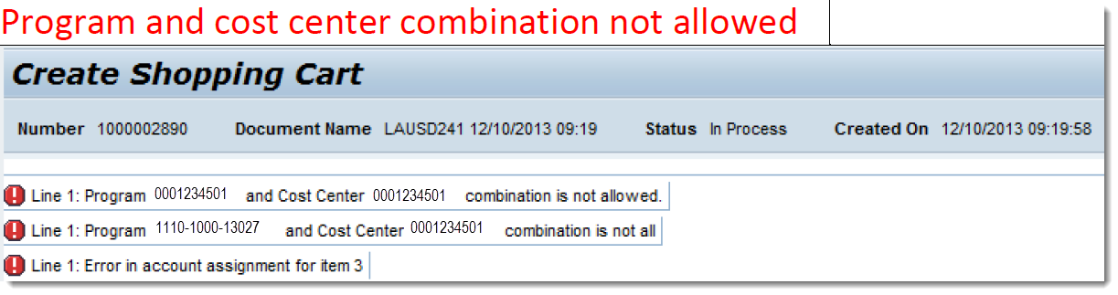

* Error occurs when program and fund center/cost center are not set up
* Contact your Fiscal Specialist

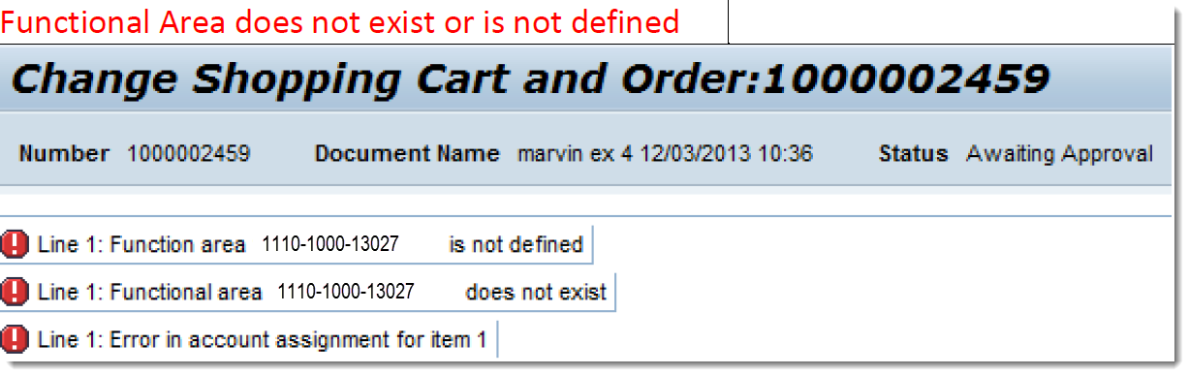

* Error occurs when invalid/wrong Functional Area was entered
* Verify the Functional Area using Budget Availability Report or COFE Budget Report

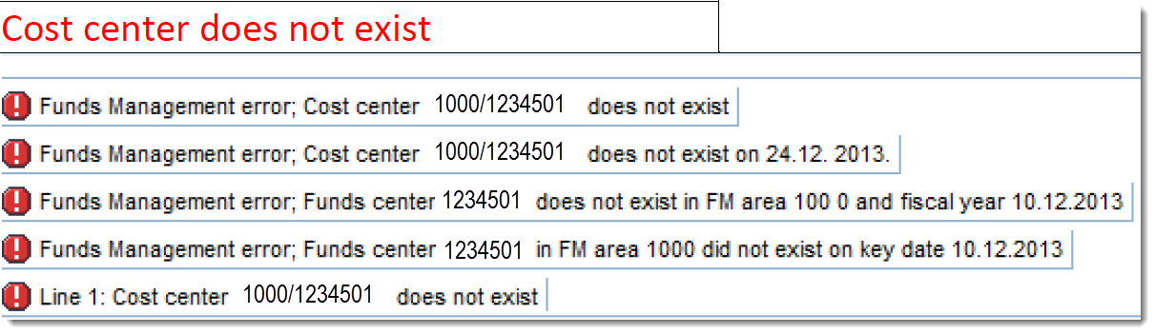

* Error occurs when wrong/invalid fund center/cost center was entered
* Verify if the fund center/cost center entered is correct

**LIST OF COMMON ERRORS**

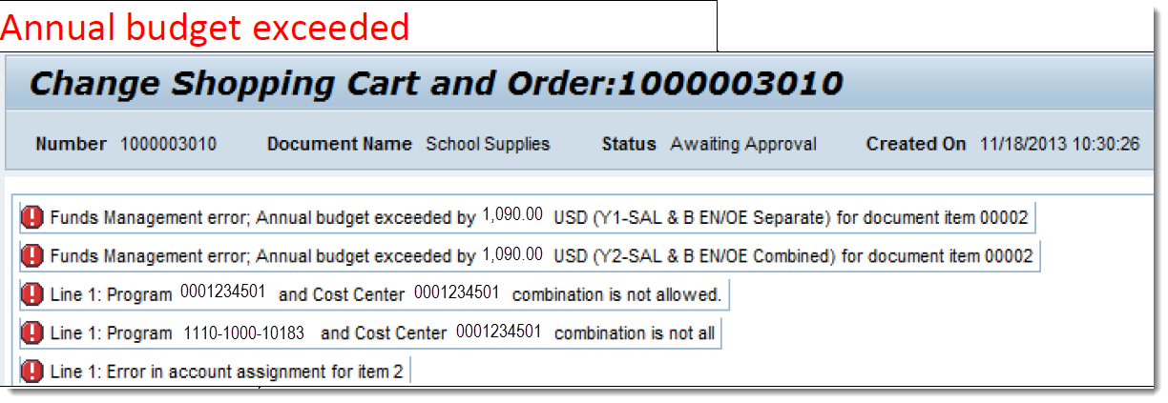

* Error occurs when amount entered exceeds available budget
* Verify available balance through Hyperlinked Control Sheets

Function and Object combination is not allowed

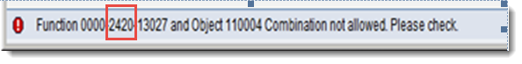

* Error occurs when Function and Commitment Item is not set up
* Contact your Fiscal Specialist