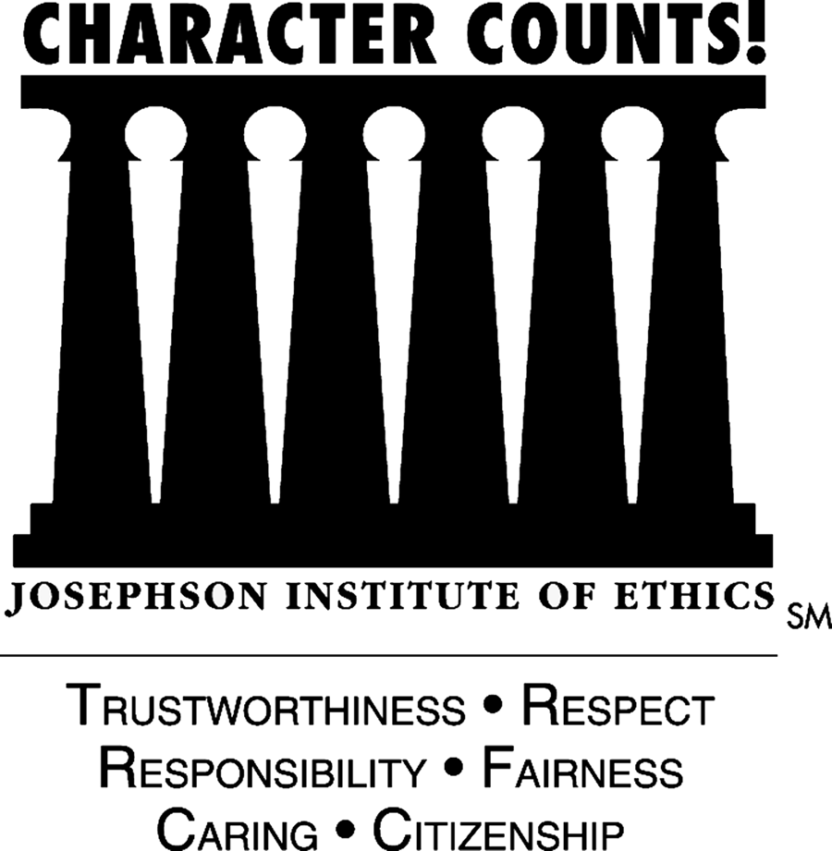
LAUSD – Middle School
Code of Conduct for Intramural Student

Intramural activity competition should demonstrate high standards of ethics and sportsmanship and promote the development of good character and other important life skills. The highest potential is achieved when participants are committed to pursuing victory with honor according to six core principles: trustworthiness, respect, responsibility, fairness, caring, and good citizenship (the “Six Pillars of Character_{sm}”). This Code applies to all students involved in intramural sports in California. I understand that, in order to participate in middle school activities, I must act in accord with the following:

TRUSTWORTHINESS
- Trustworthiness — be worthy of trust in all I do.
- Integrity — live up to high ideals of ethics and sportsmanship and always pursue victory with honor; do what’s right even when it’s unpopular or personally costly.
- Honesty — live and compete honorably; don’t lie, cheat, steal or engage in any other dishonest or unsportsmanlike conduct.
- Reliability — fulfill commitments; do what I say I will do; be on time to practices and games.
- Loyalty — be loyal to my school and team; put the team above personal glory.

RESPECT
- Respect — treat all people with respect all the time and require the same of other students.
- Class — live and play with class; be a good sport; be gracious in victory and accept defeat with dignity; give fallen opponents help, compliment extraordinary perform-ance, show sincere respect in pre- and post-game rituals.
- Disrespectful Conduct — don’t engage in disrespectful conduct of any sort including profanity, obscene gestures, offensive remarks of a sexual or racial nature, trash-talking, taunting, boastful celebrations, or other actions that demean individuals or the activity.
- Respect Officials — treat contest officials with respect; don’t complain about or argue with official calls or decisions during or after an activity.

RESPONSIBILITY
- Importance of Education — be a student first and commit to getting the best education I can. Be honest with myself about the likelihood of getting an athletic scholarship or playing on a professional level and remember that many universities will not recruit students that do not have a serious commitment to their education, the ability to succeed academically or the character to represent their institution honorably.
- Role-Modeling — Remember, participation in activities is a privilege, not a right and that I am expected to represent my school, coach and teammates with honor, on and off the field. Consistently exhibit good character and conduct yourself as a positive role model. Suspension or termination of the participation privilege is within the sole discretion of the school administration.
- Self-Control — exercise self-control; don’t fight or show excessive displays of anger or frustration; have the strength to overcome the temptation to retaliate.
- Healthy Lifestyle — safeguard your health; don’t use any illegal or unhealthy substances including alcohol, tobacco and drugs or engage in any unhealthy techniques to gain, lose or maintain weight.
- Integrity of the Game — protect the integrity of the game; don’t gamble. Play the game according to the rules.

FAIRNESS
- Be Fair — live up to high standards of fair play; be open-minded; always be willing to listen and learn.

CARING
- Concern for Others — demonstrate concern for others; never intentionally injure any player or engage in reckless behavior that might cause injury to myself or others.
- Teammates — help promote the well-being of teammates by positive counseling and encouragement or by reporting any unhealthy or dangerous conduct to coaches.
CITIZENSHIP
- Play by the Rules — maintain a thorough knowledge of and abide by all applicable game and competition rules.
- Spirit of rules — honor the spirit and the letter of rules; avoid temptations to gain competitive advantage through improper gamesmanship techniques that violate the highest traditions of sportsmanship.

I have read and understand the requirements of this Code of Conduct. I understand that I’m expected to perform according to this code and I understand that there may be sanctions or penalties if I do not.

_______________________________________ _________
Student Signature Date

