PURPOSE

This job aid is designed to provide Secondary Athletic Directors at secondary schools with the process to perform the following tasks:
J O B A I D
- Add Additional Rules and Forms (Pages 1-2)
- Add Students to the Athletic Group (Pages 3-6)
- Generate the Athletic Eligibility List Report (Pages 6-8)
- Transfer Students from Tryout Group to OAT (Pages 9-10)
- Generate the Athletic Grade Summary Report (Pages 10-11)
- Generate the Ineligible Parent Letter Report (Pages 11-12)
- Generate the Certificate of Athletic Eligibility Report (Pages 12-13)
- View Student(s) Athletic Page (Pages 13-14)
- Update Athletic Eligibility Documents (Page 14)
- Enter Athletic Remarks/Waivers (Page 15)
- Generate Attendance Daily Check (Pages 15-16)
LOG IN
- Log into MiSiS at http://misis.lausd.net/start using your single sign-on (SSO).
- Select the correct user role from the landing page.
ADD ADDITIONAL RULES AND FORMS

MENU PATH
- Admin > Configuration > Athletics > Athletics Group Parameters
Additional school athletic rules or forms may be added using the Athletic Configuration. If none are required, users can skip to adding students to athletic groups.
Step 1 Select the Official Athletic Group from the drop down arrow to view the District-Wide Eligibility Rules.
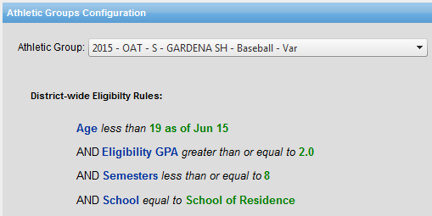
1

To add Additional Rules to the existing District-wide Eligibility Rules:
Step 2 Click the drop down arrow and select a criteria option.
Step 3 Click the drop down arrow and select the conditions.
Step 4 Click the drop down arrow and select the value.
Step 5 Click the Save button to complete the process.
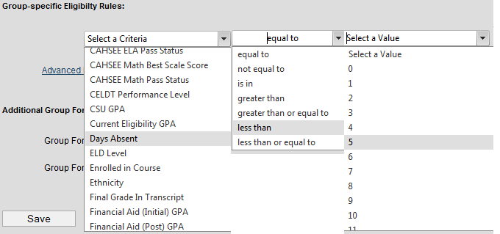
2
3
4

5

A confirmation message will appear.


The newly created rule is applied and displayed.
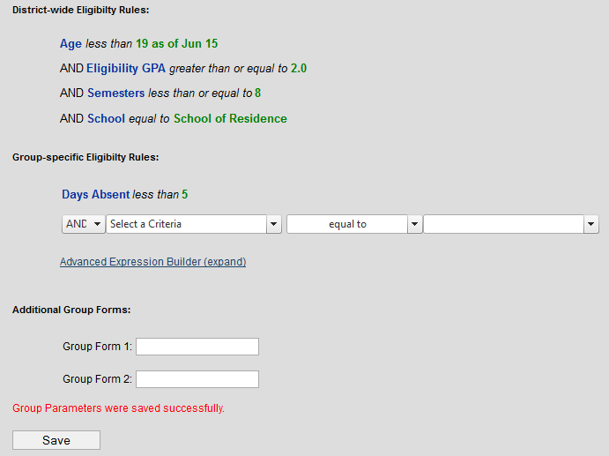

Add additional forms.

ADD STUDENTS TO THE ATHLETIC GROUP

MENU PATH
- Admin > Manage Groups
Two sets of Athletic teams have been created, the Tryout and the OATs. As an option, students may be added to Tryout groups, and later may be transferred to the OAT. User may also decide to add students directly into the OAT.
Step 1 Click the Find Group menu button.
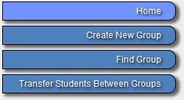
1

Step 2 Select School from the drop down list.
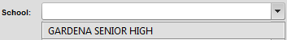
2

Step 3 Click the Athletics + sign in the Categories field to view the sports and select the desired sport.
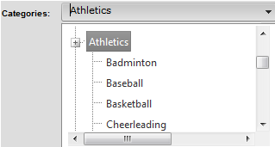
Use the scroll bar to the right and scroll down until the desired sport is visible.
3


Step 4 Click the Group drop down arrow and select the desired Group.
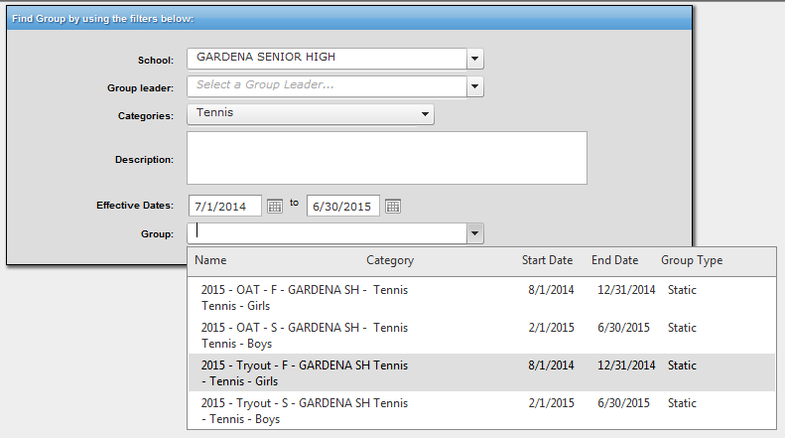
A Summary of selected group will be displayed.
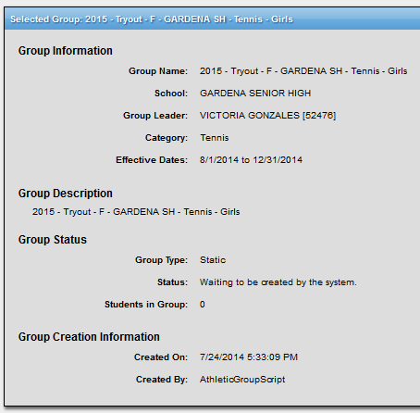

4

Step 5 Click the Edit Group Membership menu button.
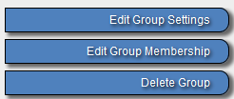
5

Step 6 Click the Search Students button.
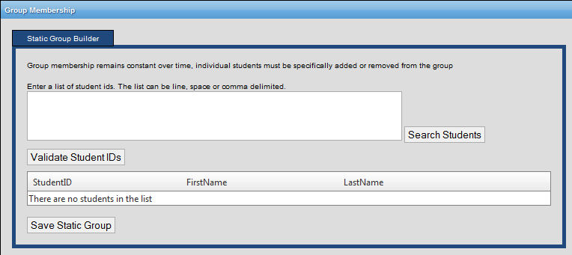

6

Step 7 Click the Advanced link.
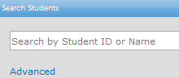
7

Step 8 Click the drop down arrow on any of the filter fields to narrow the search for your students.
Please note that the maximum number from the results will be 250 students.
Step 9 Click the Search button.
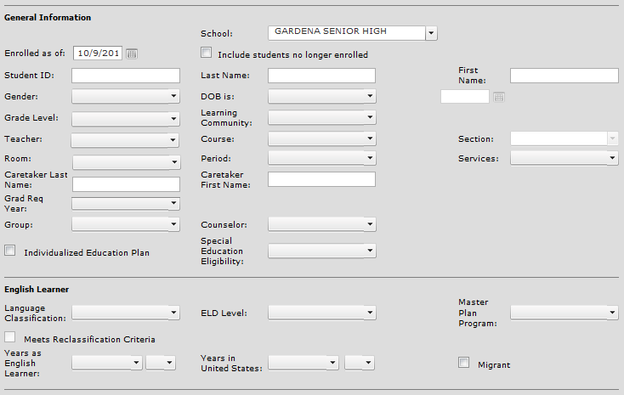
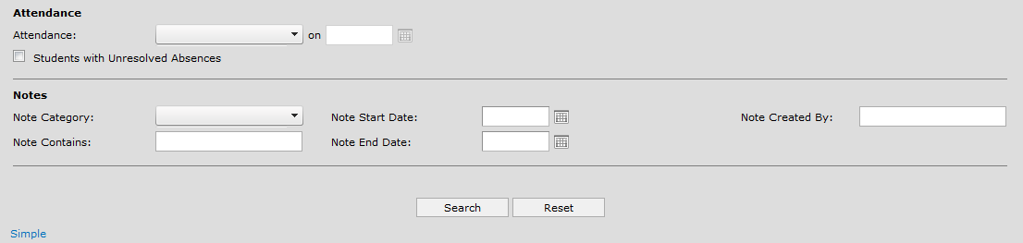
8

9

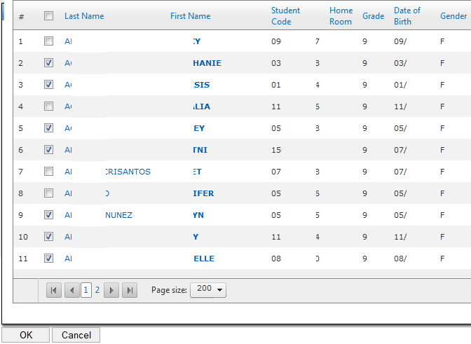
Step 10 Click in the check box next to the student’s name to add to the group.
10
11
Step 11 Click the OK button.

Step 12 Click the Validate Student IDs button.
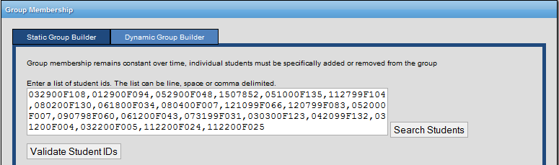
12

Step 13 Click the Save Static Group button.
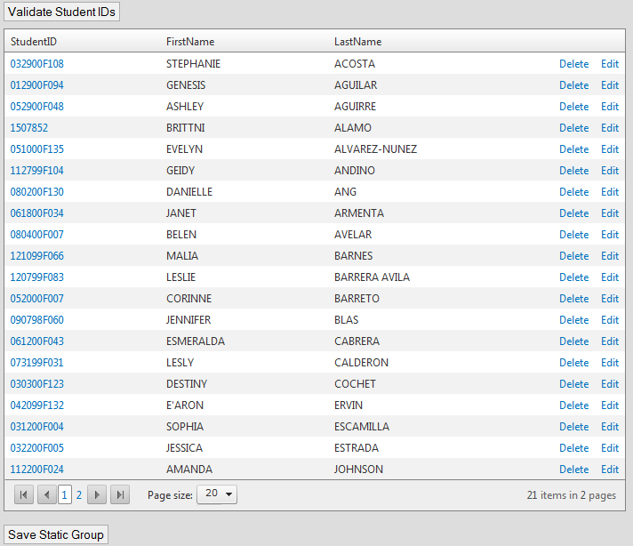
13
To add all the desired students to the group, repeat steps 8-15.

Note: If desired students appear on the following pages; the above steps must be applied one page at a time.

GENERATE ATHLETIC ELIGIBILITY LIST

MENU PATH
- Reports > Athletic Eligibility > Athletic Eligibility List
This report displays all eligibility rules and documents for each student.
Step 1 The parameter screen and the prepopulated default values are displayed below. Additional values become available as parameter selections are made.
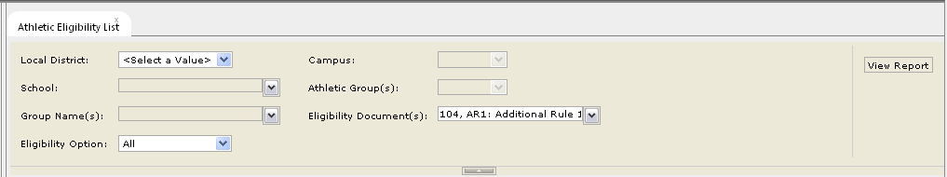

A brief description of each field follows, in the order of selection:
- Local District - Select the Local District that the school is located in.
- Campus - Select the main location. All reports include a Campus parameter in order to select all OATs within that campus.
- School - Select the school or magnet.
- Athletic Group(s) - Select the activity.
- Group Name(s) - Select the Official Athletic Team(s) (OAT).
- Eligibility Document(s) - Select the applicable documents to verify.
- Eligibility Option - Select the desire option.

Make sure to enter the parameters from left to right, and top to bottom – this allows the values in the drop-down menus to populate accurately.
Please note that as selections are made from a parameter drop-down list, users may need to either click on the corresponding drop down arrow or click anywhere within the gray parameter window to collapse a list.
Step 3 Complete the parameters as required. A completed sample is shown below.
Step 4 Click the View Report button.
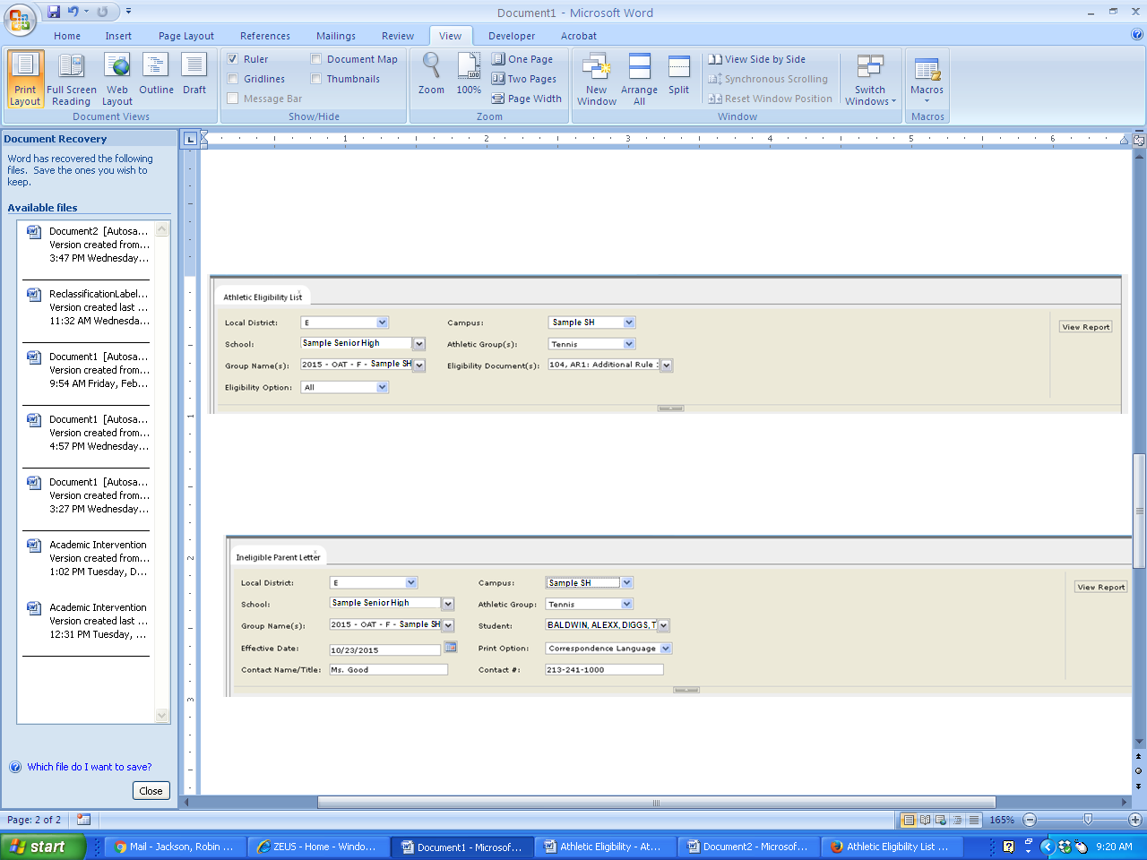
4
3

Step 5 Click on the Export icon to export data.
Step 6 Select a file type. In this example, PDF was selected.
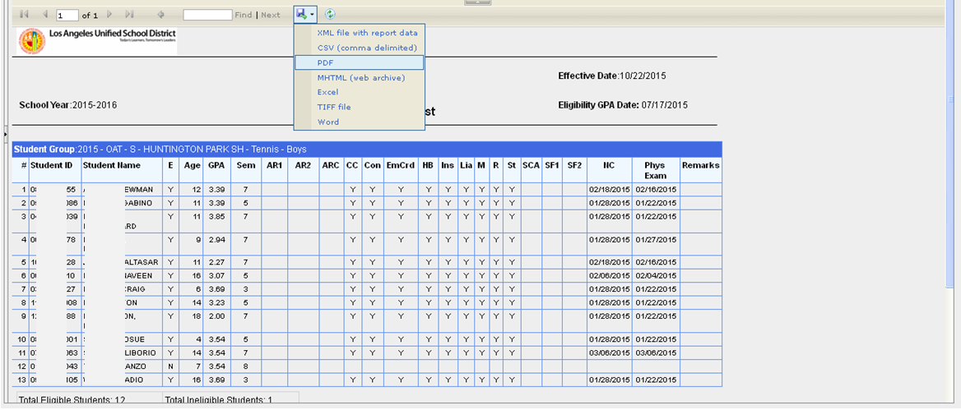
5

6

The AR1, AR2, SF1 and SF2 will display data if these were added in Athletic Configuration.

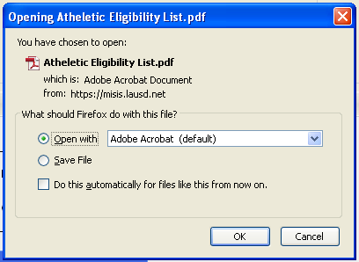
Step 7 Select the radio button option to open the file.
Please note that the pop-up window display may vary, depending on the internet browser used.
7

Step 8 Click the OK button.
8

Step 9 Click on File from the Menu toolbar or select the Print icon from within the application to print the transcript. In this example, the Print icon was selected.
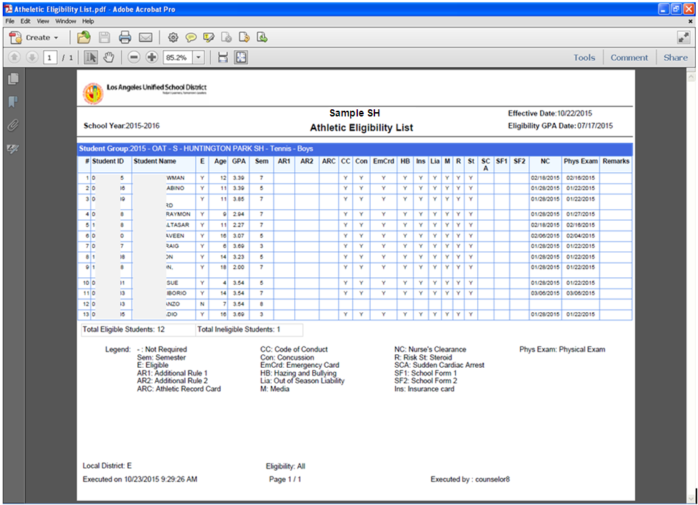
9

TRANSFER STUDENTS FROM TRYOUT GROUP TO OAT

MENU PATH
- Admin > Manage Groups
Once students have been added to the Tryout group, students that met the minimum requirements as summarized in the Athletic Eligibility List and past tryout can be transferred to the OAT.
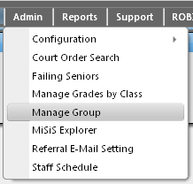
Step 1 Click the Admin menu button.
1
Step 2 Select the Manage Group option.
2

Step 3 Click the Transfer Students Between Groups menu button.

3

Step 4 Click the Group: drop down list arrow.
Step 5 Select the Tryout Group of students to transfer from. (For this example, 2015 – Tryout – F - Sample SH – Tennis – Girls was selected, but in production Sample SH will be replaced by the actual name of your location).
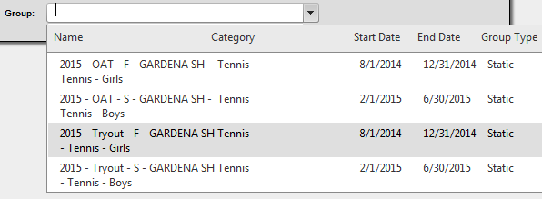
5
SAMPLE SH
SAMPLE SH
SAMPLE SH
SAMPLE SH
4

Once the Tryout Group is selected, the students’ codes, last and first names, gender and grade will display.

Step 6 Click the drop down list arrow for the Select a Group option on the right.
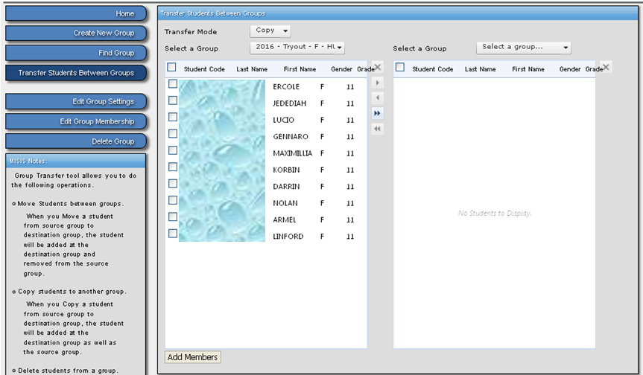
6

SA
Step 7 Select the matching OAT Group to transfer to. (For this example, 2015 – OAT – F - Sample SH – Tennis – Girls was selected, but in production Sample SH will be replaced by the actual name of your location).
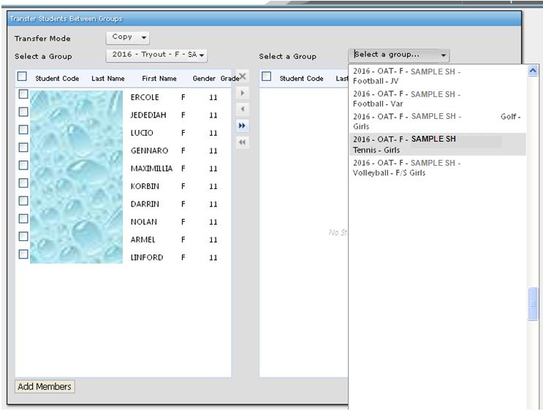

7

There are multiple ways to select students to transfer.

Step 8a To transfer all students listed from Tryout to OAT status, either….
Click the checkbox to the left of the Student Code column heading.  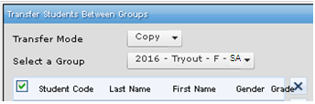  Click the single chevron button located between the left and right panes  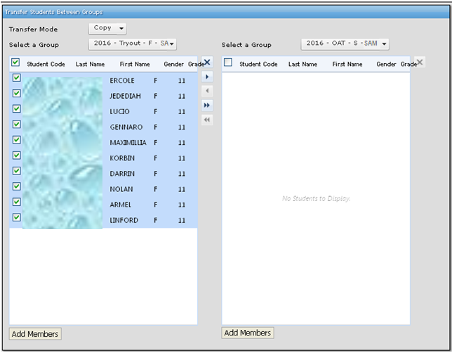 | -OR- | Without selecting any checkbox, click the double chevron button located between the left and right panes.  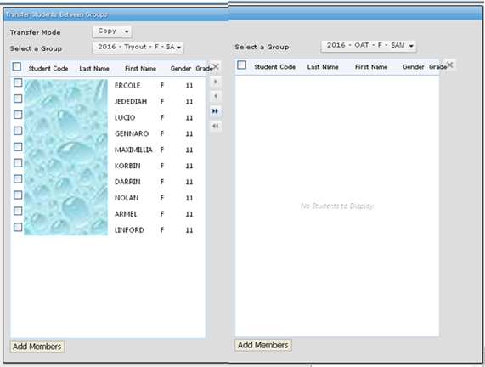

Step 8b To transfer various students listed from Tryout to OAT status….
Click the checkbox next to the name(s) of each desired student.
Click the single chevron button located between the left and right panes
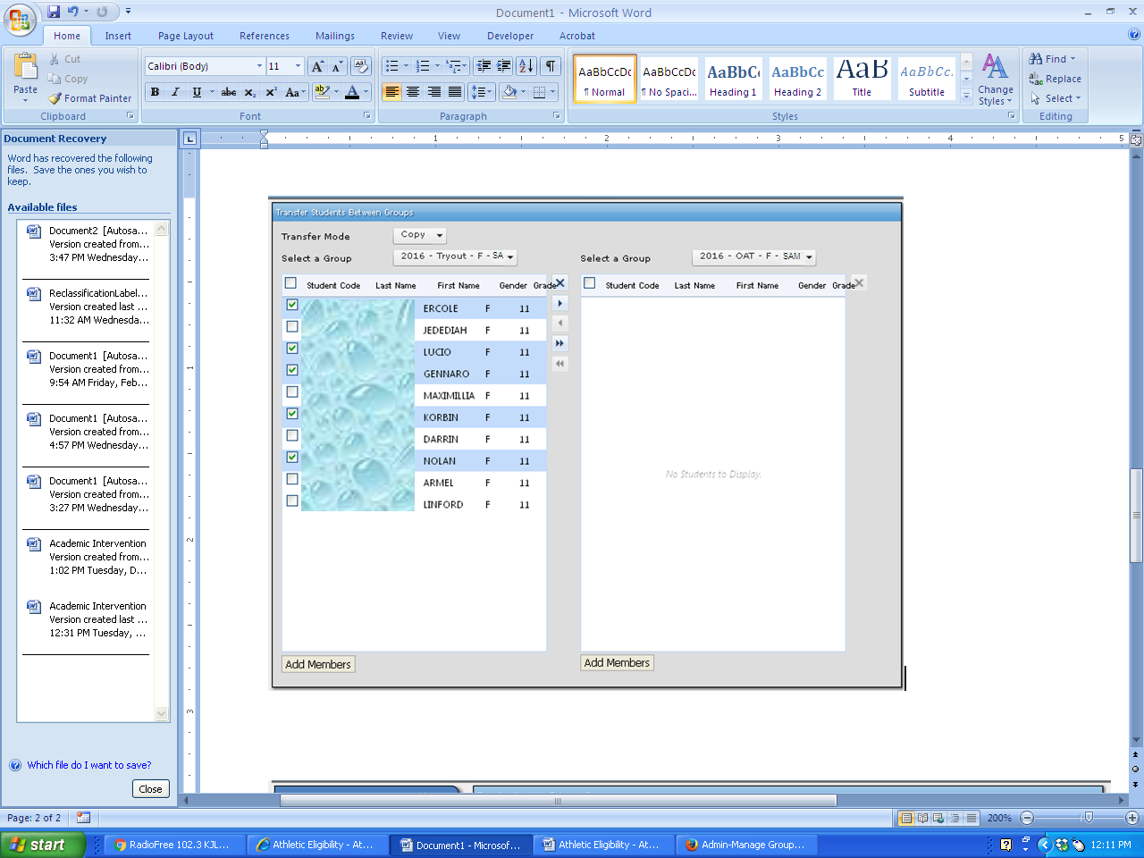

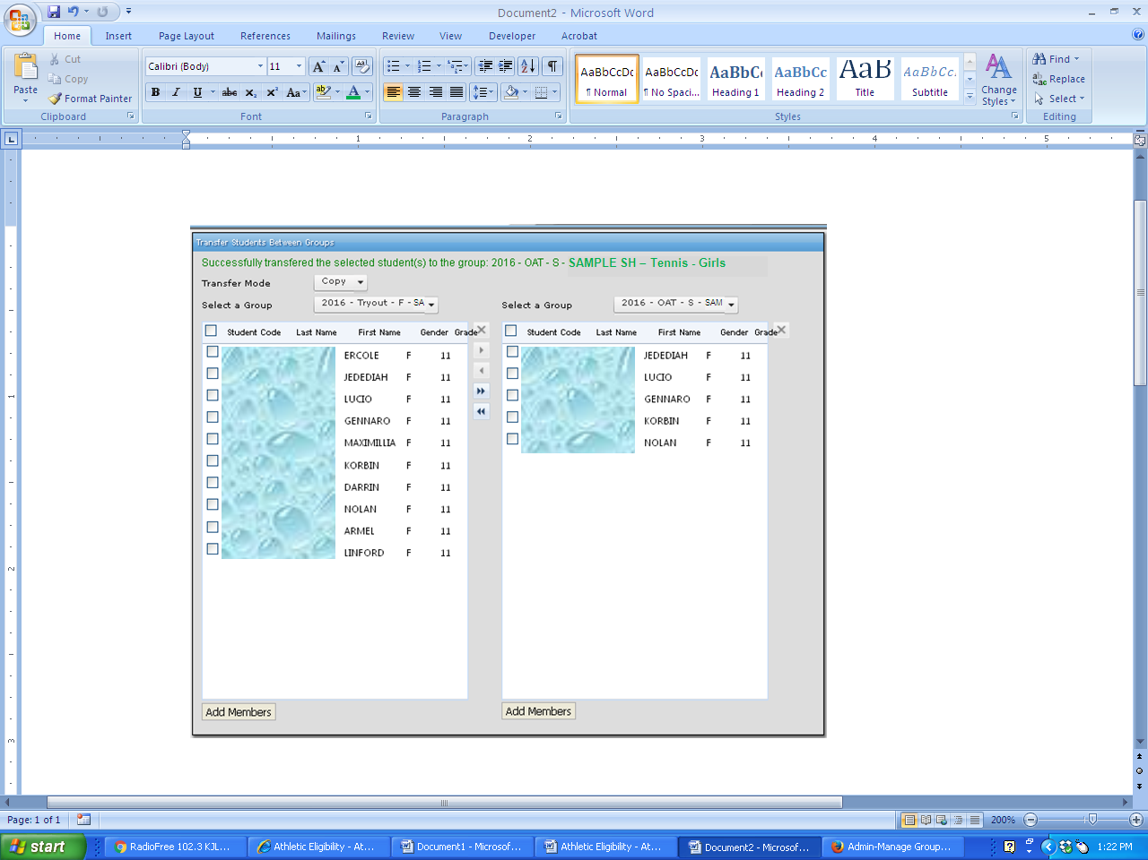
The system will display a successful message across the top of the screen.
Students are successfully added to the OAT Group.

GENERATE ATHLETIC GRADE SUMMARY

MENU PATH
- Reports > Athletic Eligibility > Athletic Grade Summary
This report displays the Athletic Eligibility GPA and the grades for the courses associated with that GPA.
Step 1 Enter the parameters and click View Report button.
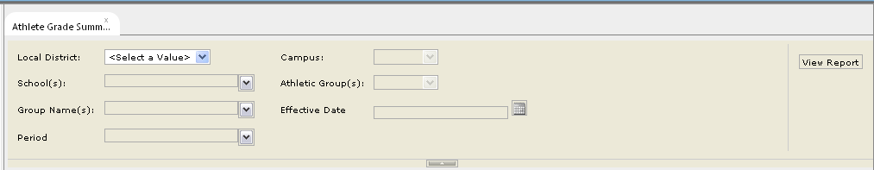
1

The report will display.
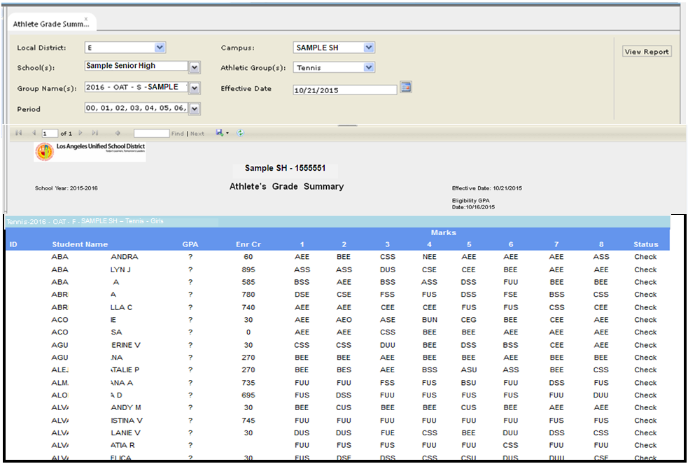

GENERATE INELIGIBLE PARENT LETTER

MENU PATH
- Reports > Athletic Eligibility > Ineligible Parent Letter
This report will generate a letter to be mailed to parents for each student that does not meet the athletic eligibility requirements.
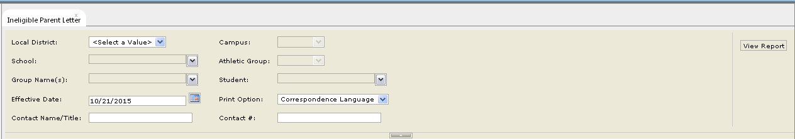
Step 1 Enter the parameters and click View Report button.
1

The report will display.
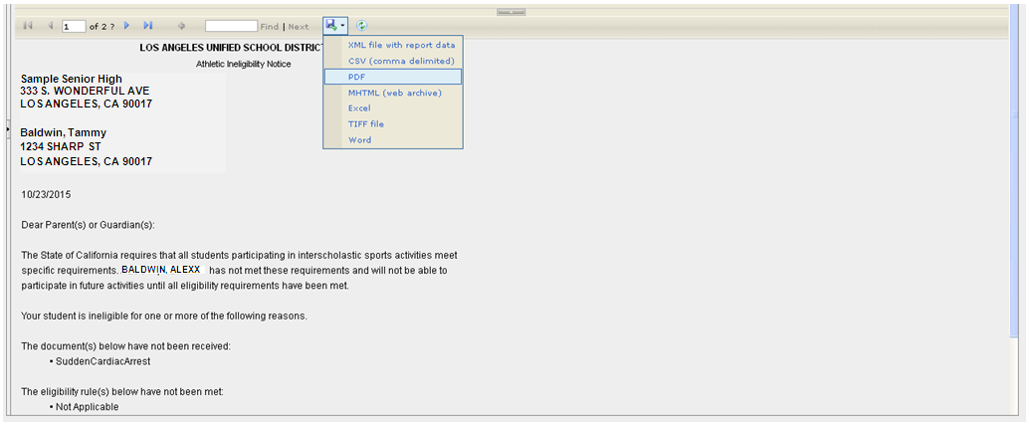

GENERATE CERTIFICATE OF ATHLETIC ELIGIBILITY REPORT

MENU PATH
- Reports > Athletic Eligibility > Certificate of Athletic Eligibility
This report will only include students that have met all of the athletic eligibility requirements.

Step 1 Enter the parameters and click View Report button.
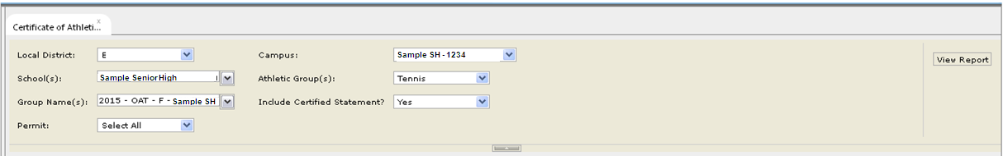
1

The report will display.
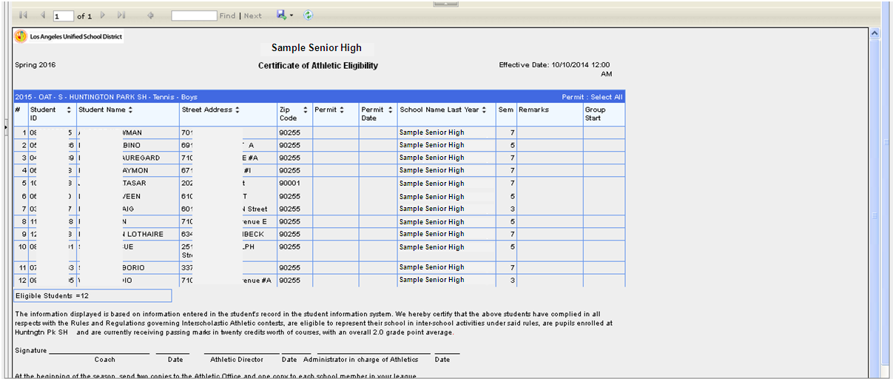

VIEW STUDENT ATHLETIC PAGE
Step 1 Click the Advanced link.
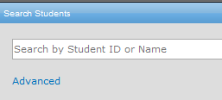
1

Step 2 Locate and click the Group: field drop down list arrow and select a group from the list.
Step 3 Click the Search button.
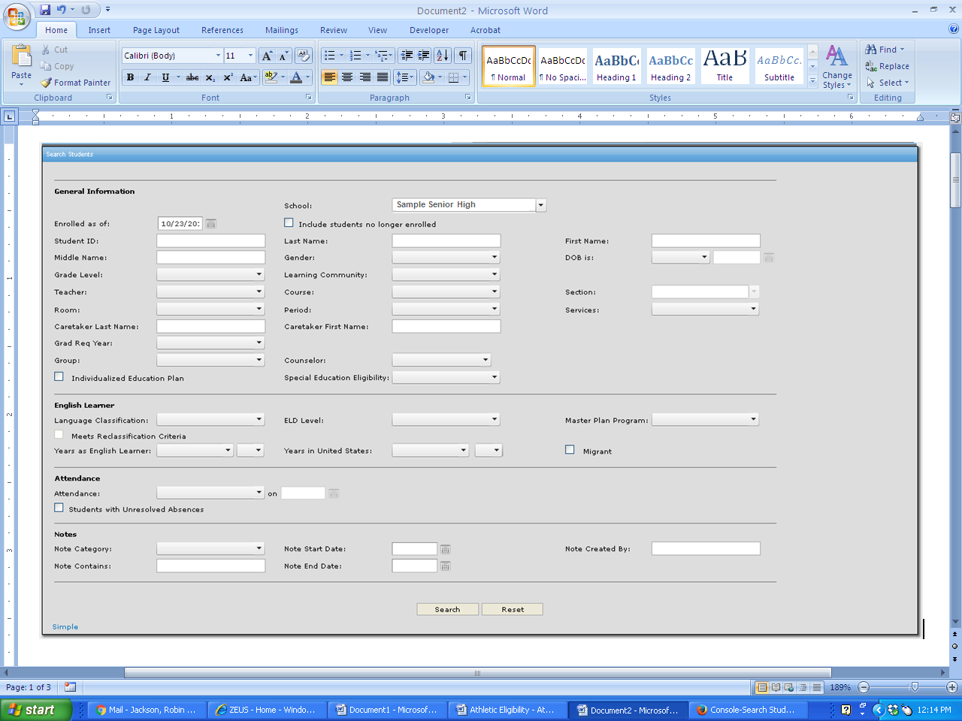
2
3

Step 4 Click on the desired student’s name.
4

Step 5 Click the Miscellaneous link.
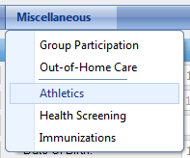
Step 6 Select Athletics from the list.
6
5

The Overall Athletic Eligibility screen for the selected student will display.
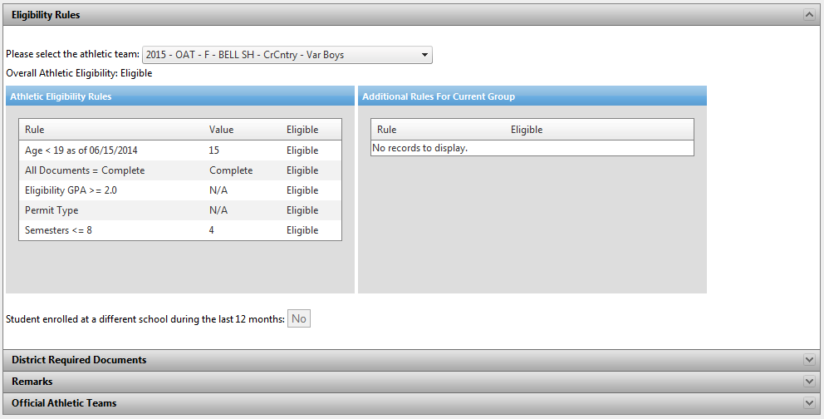

UPDATE ATHLETIC ELIGIBILITY DOCUMENTS

Step 7 Click the arrow to expand the window and enter dates for District Required Documents.
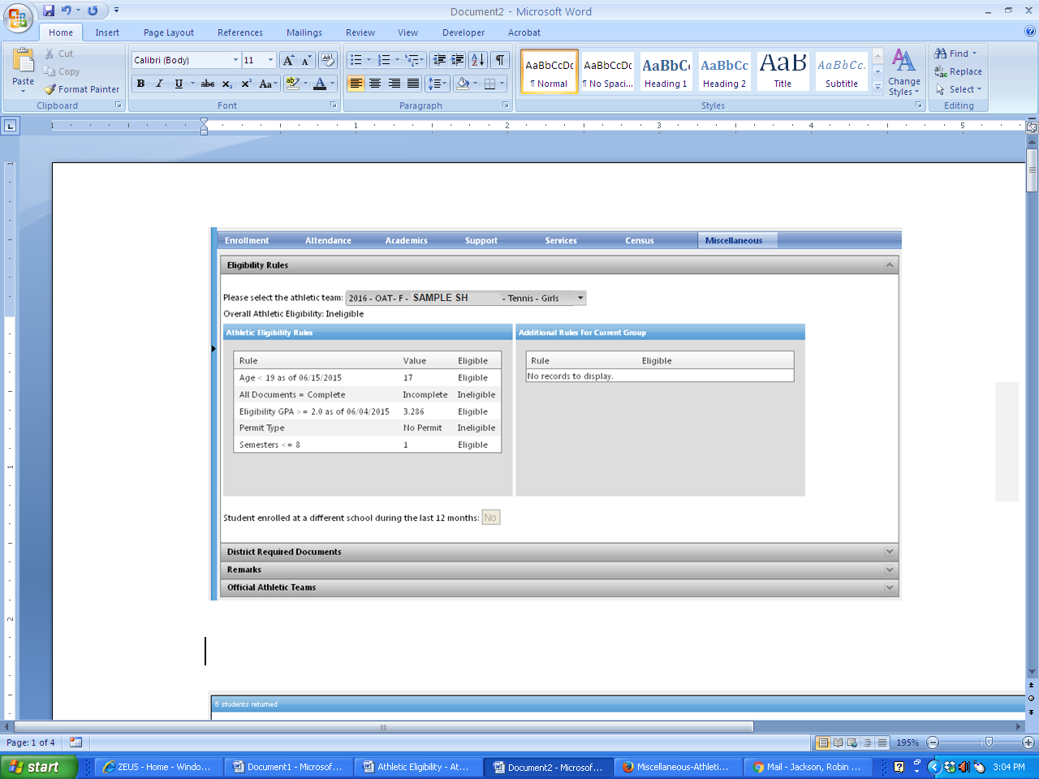
7

There are multiple ways to record the Date(s) Submitted.

Step 8a To apply the same date to all fields, except the Physical Exam and Nurse’s Clearance fields, click the calendar icon at the Apply to all: field and select a date. (Once the date is selected, it will display in each field, except the two mentioned above).
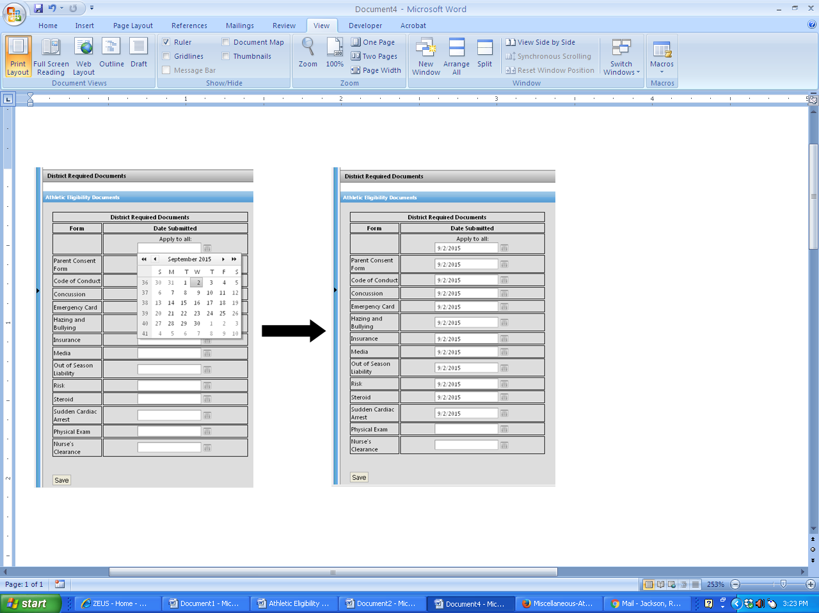
8a

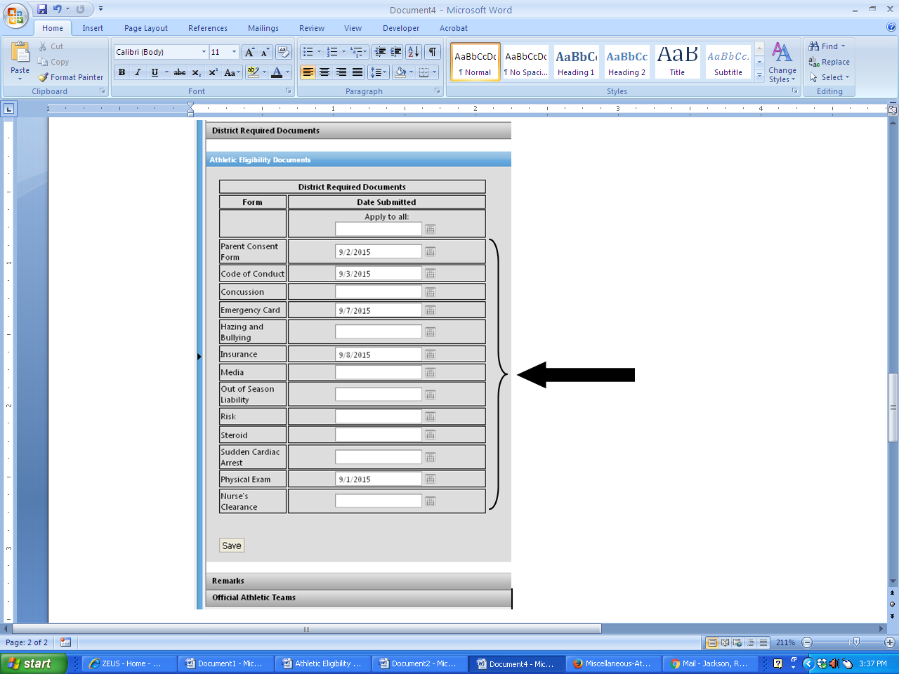
Step 8b To apply various dates to the fields, click each individual calendar icon and select a date.
8b
9

Step 9 Click the Save button to save updates. (The message, Save successful should display above the Save button.)

ENTER ATHLETIC REMARKS

Step 10 Click the arrow to expand the window and enter Remarks data.
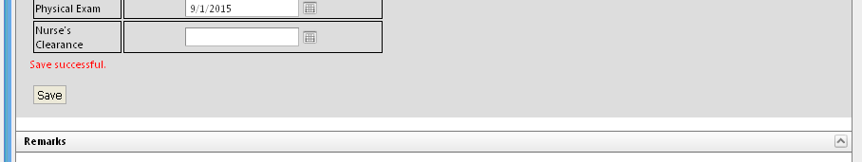

10

Step 11 Click the Remark drop down list arrow and select the appropriate option from the list.
Step 12 Enter comments if applicable.
(The Approved By: field will default to the name of the logged in user, but can be changed by clicking in the field and replacing the text. The Approved Date: field will default to the current date, but can be changed by clicking the calendar icon and selecting a different date.)
Step 13 Click the Save button to update screen.
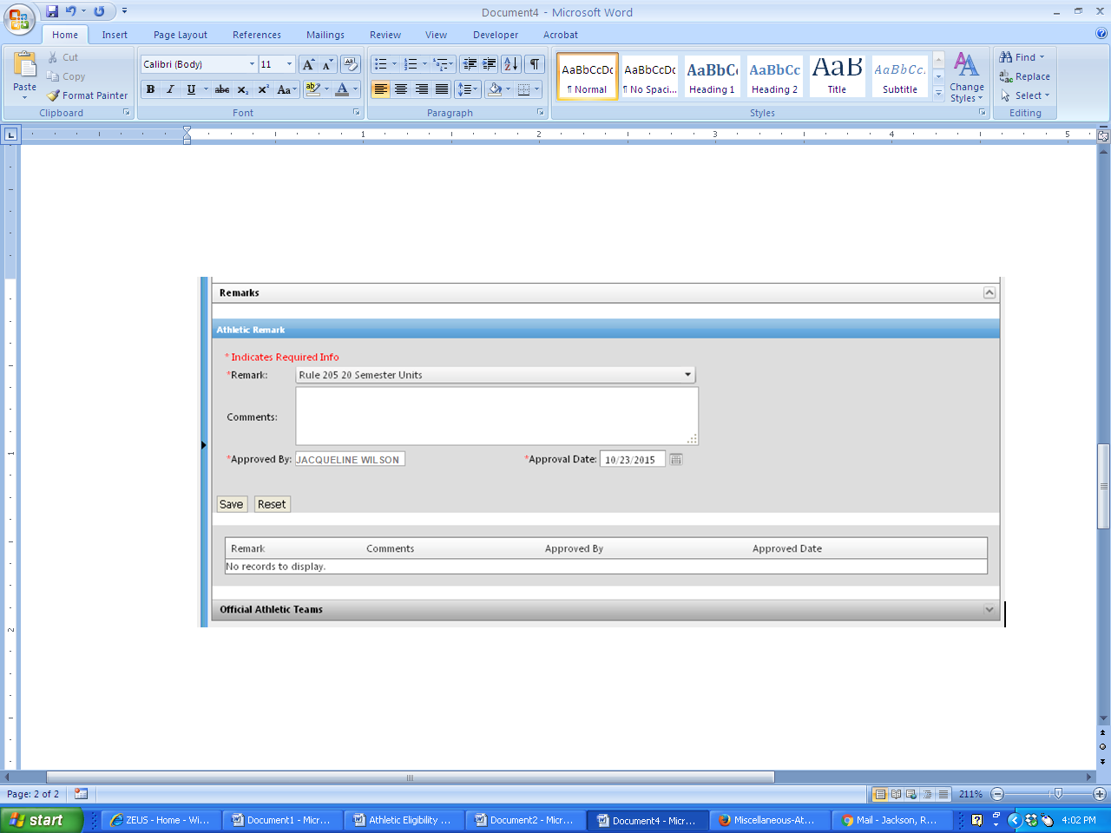
11
12
13

The saved information will display in the Remark view area.
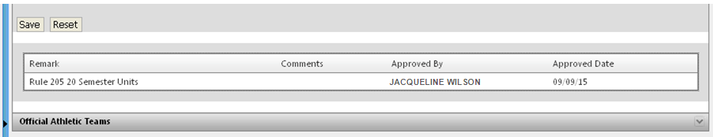

The only two Remarks/Waivers the system will override are the following:
- 203 Age Requirement - Age 19th birthday is on or before June 14 is ineligible; Football Varsity: cannot be younger than 14 as of 8/1 unless a waiver is entered
- 204 Charged Semester of Attendance
GENERATE ATTENDANCE DAILY CHECK

MENU PATH
- Reports > Athletic Eligibility > Attendance Daily Check
This report displays the attendance for the selected game to determine whether the student is eligible to participate in the game or not.
Step 1 Enter the parameters and click View Report button.
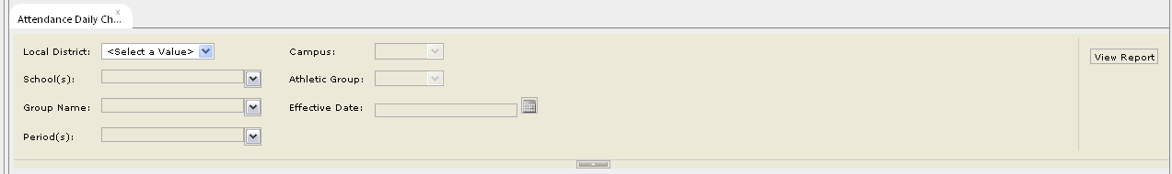
1

The report will display.
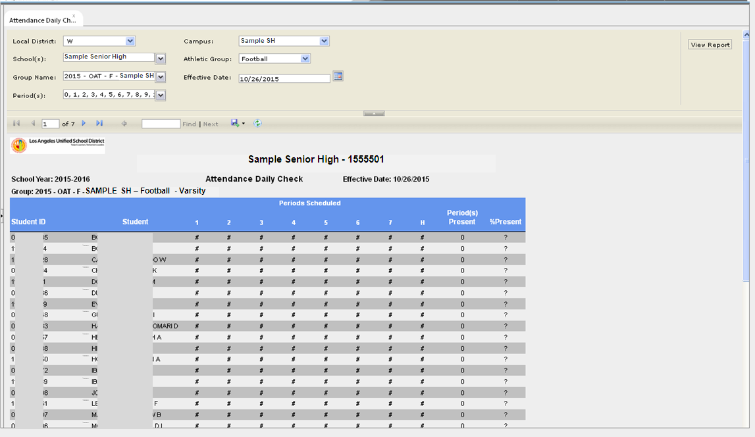
This report is to be generated the day of the game to verify that the student was present and is eligible to participate.

